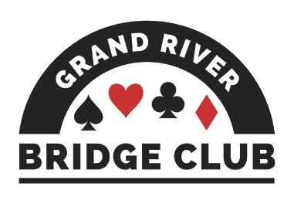PLAY AND LEARN BRIDGE IN A WELCOMING ENVIRONMENT245

ALERT – May 8, 2023

Click here to access our regular game schedule.

Looking Ahead

 Both of today’s F2F games (Friday, May 5) will be club championship games (extra masterpoints, no extra cost).
 Sectional Tournament in Barrie, Saturday, May 6 – Sunday, May 7
 Grass Roots FUNd Week, May 8-14 on BBO, double black points, BBO$7
 Canadian Bridge Championships, Niagara Falls, May 9-19
 Canadian Bridge Federation Regional, Niagara Falls, May 12 – May 19
 All of our F2F games during the week of May 22 will be club championship games (extra masterpoints, no extra cost).

--------------------------------------------------------------------------------------------------------------------------------------------

Congratulations
to the following local players who have advanced to the next ACBL level. Junior Master
- Randall DeKraker
Club Master
- Phil DeMontigny
Regional Masters
- Renate Boucher
- George Pepall
NABC Master
- Tony Verhoeven
Life Master
- Adriaan Kempe

And a warm welcome to the following new ACBL members.
- David Bell
- Louise Bell
- Stephen Cameron
--------------------------------------------------------------------------------------------------------------------------------------------

Adventures with Barbara Seagram – Pictures Worth 1000 Words

Last Wednesday, Barbara Seagram was at our club, along with about 90 of her closest friends. It was a wonderful day, with a workshop on tricks out of nowhere in the morning, a fabulous lunch, and a fun game in the afternoon. We owe a great debt of gratitude to the four organizers: Anita Hanson, Debbie Miethig, Barb Neibert, and Audrey Cook. The day was extremely well organized, and it’s impossible to thank everyone who pitched in – but special thanks to Joe Blake who made sure everyone parked in the right spots and Al Pengelly who ran the two-section game. Also Marylynn Benjamins, Bob Livermore, and Sue Peterson. Photo credits: Anita Hanson, Joan Slover, and Al Pengelly.

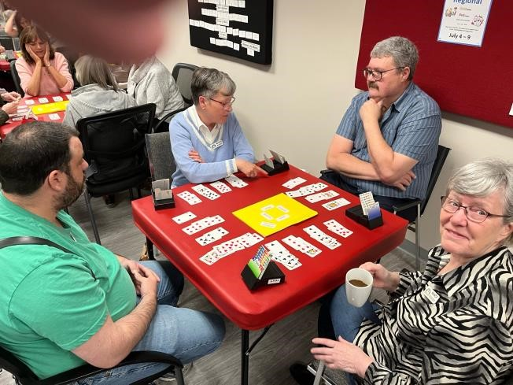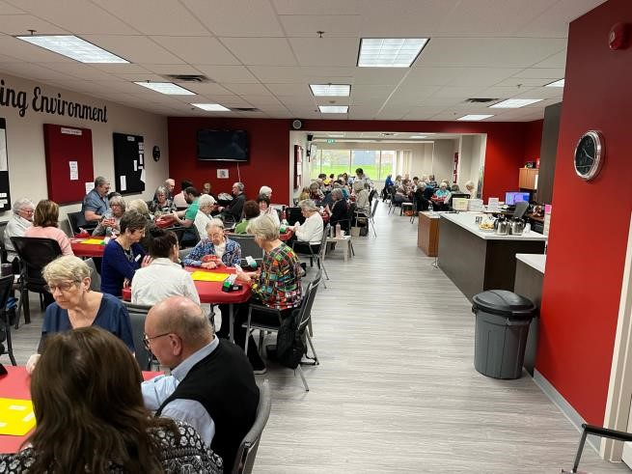

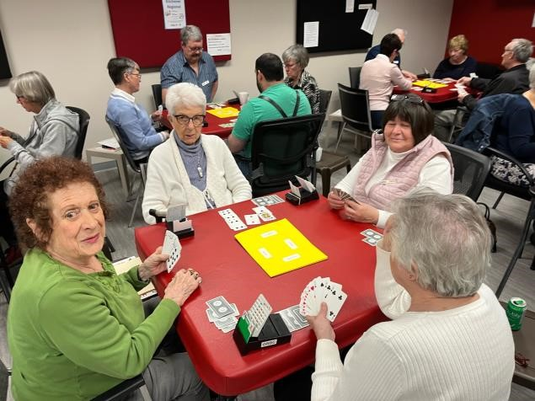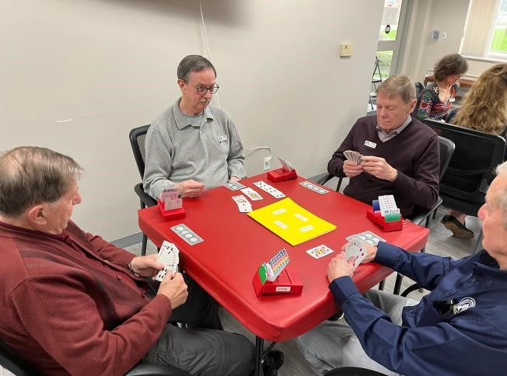

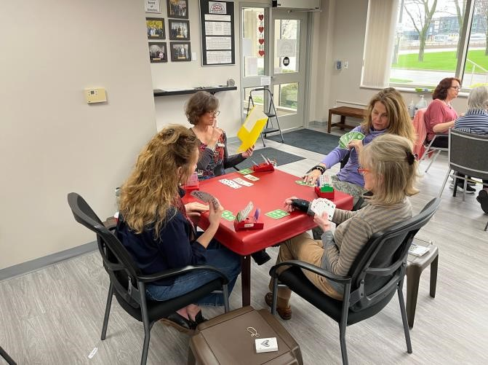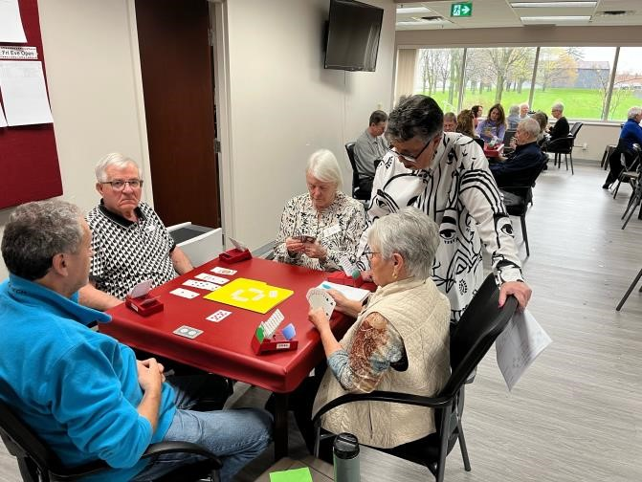

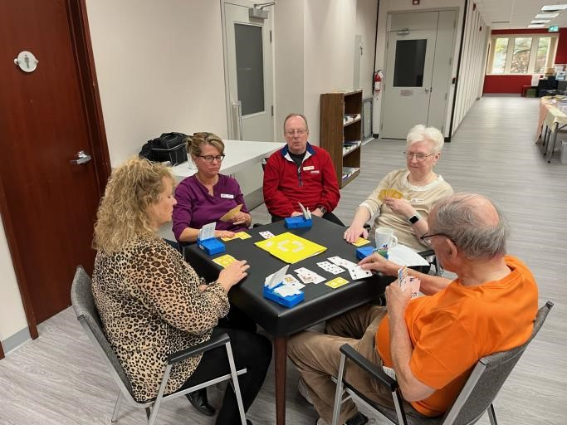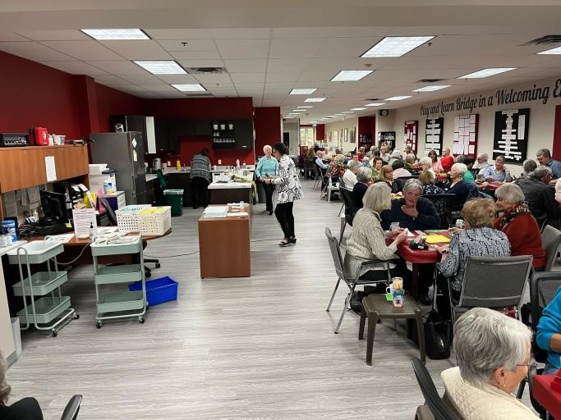

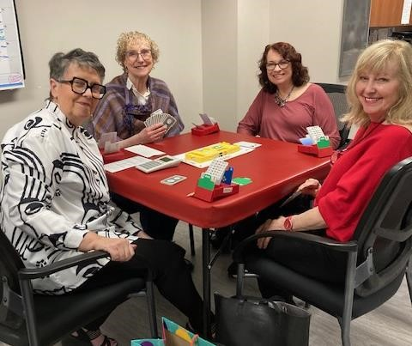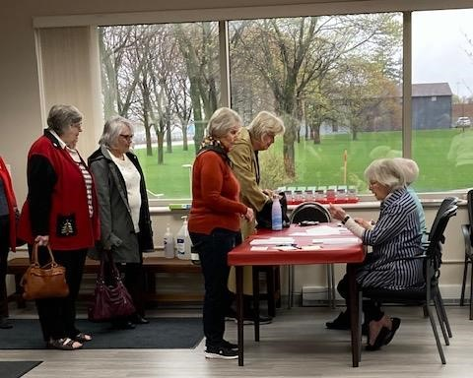

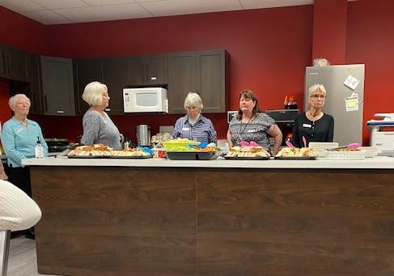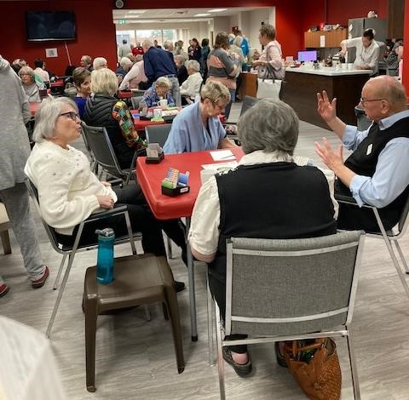

In all the excitement, Betty Robinson lost a pearl earring. If you come across it, please let Betty know.

Our Club’s Management Team
Although (hopefully) our club appears to operate smoothly and effortlessly – you know, you show up for a game and it runs and you have fun; you show up for your lesson and your teacher appears and you learn a lot – in fact it takes a huge amount of work behind the scenes to make it appear so effortless. And virtually all of this work is performed by volunteers.

This is the third in a series profiling the current members of our club’s management team and thanking them and their predecessors for their stellar work. Next up is our dealing lead (and our club’s newest life master).

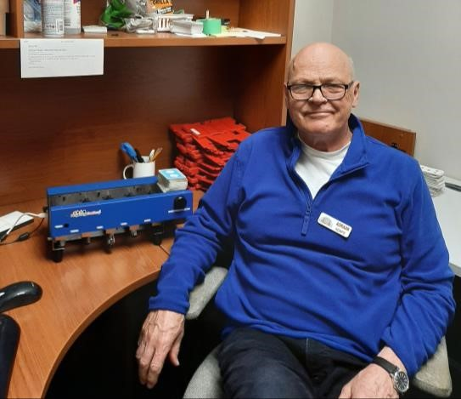 Adriaan Kempe

Most of the time we start by thanking the profiled volunteer’s predecessor, but not this time. That’s because Adriaan has no predecessor. That’s right, Adriaan has been doing his job for something like 10 years now, ever since our club got its dealing machine!

That was back in 2013, and as Adriaan tells it, everyone had cleared out after a game except him and the director, Dave Baker. When Adriaan innocently asked Dave if there was anything he would like help with (thinking along the lines of cleaning up the kitchen or taking out the garbage), Dave walked him to the back room where the dealing machine was, gave him two minutes’ instruction, and said you are now the dealer. Adriaan refers to it as been voluntold.

Adriaan describes his job as co-ordinator of the dealing team. (The team currently consists of Elinor Girouard, Rebecca Kalbfleisch, Sandy Graham, and Neil Jeffrey). Along with this team, Adriaan prepares the boards for all of our face-to-face games, including the more complicated STaC games and other special contests. In addition, Adriaan has dealt boards for six sectional tournaments and one regional tournament, with another one coming in July.

Although he was born in Holland, Adriaan came to Canada when he was only a toddler and thus doesn’t have much if any Dutchness left. However, he is an environmentalist who loves to garden and even has a few tulips, so perhaps the seed didn’t fall too far from the flower after all.

Bridge first came to Adriaan’s attention when his father-in-law was part of a group that played kitchen bridge every Tuesday night - which Adriaan thought was kind of neat. Once he retired, he happened to see our club on the TV news and decided to check it out. At first, he was shocked by how little he knew about the game. But he enjoyed being forced to think and really loved the social aspect of the game, making lots of friends – in fact, he is part of a group of eight bridge players who have been having breakfast together once a month for years.

Lastly, Adriaan loves the unpredictability of the game, speaking fondly of the time he went down six in a contract and got a top board. And there there’s the time when Adriaan and his partner had a combined total of 33 HCP but went down five…. That’s bridge for you.
--------------------------------------------------------------------------------------------------------------------------------------------
Gatlinburg Redux
Contributed by Jennifer Verdam
Last autumn I was informed that as Chair of the Women’s Employee Resource Group for Compass Minerals, I was expected to attend the Women in Mining Conference in Tucson, Arizona. I was briefly horrified because I misread the dates and it looked as though it conflicted with Gatlinburg. I considered sundry solutions, up to and including inventing a family member with a lifethreatening illness, pretending to develop a life-threatening illness, actually developing a lifethreatening illness, resigning my position as Chair, and/or resigning my job. Overkill? I think not. Fortunately, it turned out that the Women in Mining conference took place April 12 through 14, while Gatlinburg started on the 16th, so It was not necessary for me to make any major lifealtering decisions.

I had never been to Arizona before and I thoroughly enjoyed it, although the cab driver who took me to the Tucson-Sonoma Desert Museum probably got tired of me pointing out things like saguaro cacti (basically the southwestern Ontario conifer of Arizona. There are approximately 350 million billion of them in Tucson alone. I am pretty sure he didn’t find them worthy of commentary, or at least not THAT MUCH commentary). The Desert Museum is totally worth a visit if you’re ever in Tucson by the way. It is particularly lovely in April because all of the cacti, including the saguaros, are in bloom around then.

I flew out of Tucson at 5:22 am (I know. It was the only flight that was getting me to Gatlinburg before 10:00 that night. I can sleep on planes.). I had a short layover in Dallas and then arrived in Knoxville ten minutes early. Serendipitously, Adrian, Bob, and Peter also arrived ten minutes early, probably hoping for the moral high ground. If so, they were unsuccessful. I collected my bags, which took up only about the same amount of space as everything everyone else had brought plus Bob and Peter (hey, I was gone for TWO WHOLE WEEKS). We got them packed into the car through sheer topographic skill, using only the smallest of holes in the space-time continuum. Don’t ask me how. That’s Bob’s department.

We drove from Knoxville to Gatlinburg, a trip which takes about an hour and a quarter and passes through the Smoky Mountains. It was a lovely drive, and one which took us past roughly 350 million billion Pancake Houses and Waffle Barns. There are more of them there than there are Starbucks in Seattle. There may actually be more than there are saguaro cacti in Arizona. My travelling companions certainly felt the same way about me pointing all of them out as my Tucson taxi driver did about the cacti. It’s nice to be consistent.

As Margot mentioned in last week’s Alert, her group had a fairly major mishap on the way to Gatlinburg, and we were forced to celebrate Dave Longstaff’s skills in driving by giving him a large scotch (ok several large scotches) when he finally arrived at our door. All joking aside, it was really frightening and we were all extremely thankful that they escaped with only some damage to the van.
Last year, because it was the first year back after Covid, table counts were about 45% of the level they had been in previous years. This year when we walked in on the Monday it was immediately obvious that the attendance was up. Last year they had the room subdivided and were using only half of it. This year, they had the full room and it was mostly full even on the Monday. I played with Adrian all week except for Tuesday and Wednesday when I played with Dave Longstaff.

Playing with Dave, in second seat, white against white, I picked up this hand.
♠ —
♥ K J x
♦ A K x x x ♣ Q J x x x

Adrian and I play that all two-suited descriptor bids are capped at 11 points but Dave L and I don’t.

The auction began E 1 Jenn 2NT At which point I realized that in fact East opened TWO hearts. Oh frabjous day!

E 2 | Jenn 2N (should be 14+-17 balanced). Oops! | W Pass | Dave 3 (transfer of course)
E Pass | Jenn 3N (Shut up! Shut up! Shut up!) | W Pass | Dave 4♣ (Oooh! Super-accept! Let’s cue bid.)
E Pass | Jenn 4 (This is Gerber. What have I done?) | W Pass | Dave 5♣ (Excellent! Jenn has a  card. I have a second ♣ card!)
E Pass | Jenn 5♦ (Still Gerber. What do I do if he bids 7???) | W Pass | Dave 6 (She has nothing more to say and has finally accepted the transfer.)
E Pass | 6NT (Oh please please please…) | W Pass | Dave Pass
E Pass | Sigh of relief (sort of)

The lead is a small heart and Dave came down with
♠ A Q 10 x x
♥ —
♦ Q x x
♣ A K x x x

I played the heart off the board to East’s ace and my small heart. I had one heart trick, one spade trick, three diamond tricks, and five club tricks for sure. If they finesse the spade for me, I have another trick, and if diamonds split I have two more tricks, so it’s not impossible.

If diamonds don’t split, it will be easier to bamboozle the opponents if they remain unaware of the spade position and so I must put off playing spades for as long as possible. Which is literally now, because East switched to a spade at Trick 2. I sighed and pitched the jack of hearts.

Dave looked very puzzled and said, “No spades, partner???” I looked sheepish and say, “No spades”. East said to West, “Can she bid that with a void?” I said, “I apologize. It was intended to be unusual.” East said, “That’s going to be a swing because I don’t think our partners will bid that way.” My internal voice said, “You think?” Out loud, I apologized again for screwing up, saying that my partner was unaware, which is obviously true, and we returned to the play.

West played the spade nine and I won the ten on the board. I played the queen of diamonds and a small diamond to my hand, as East showed out. My heart sank. I played a club to the board and a club back to my hand.
This was the current position.
♠ A Q x
♥ —
♦ x ♣ A x x
N
W | E
S

♠ —
♥ K
♦ A x x ♣ J x x

I led a club to the board and West, who started with Jxxx of diamonds and Jxxx of spades, thought for a bit and finally pitched a diamond. I played a diamond to my hand and claimed. One spade, one heart, five diamonds and five clubs. If West pitches a spade, I can cash the ace and the 10 will grow up. I could pretend I worked it out in advance, but the truth is I missed the fact that the squeeze was on because it literally only works if East opened 2 with six hearts and four spades, which is not a holding I would have ever expected from a first seat pre-empt. At the other table they had a somewhat more normal auction, ended up in 3N, and also made six.

The full deal was as follows.
♠ A Q 10 x x
♥ —
♦ Q x x
♣ A K x x x
 | N
W |  | E
 | S
♠ J x x x ♠ K x x x
♥ 10 x x x ♥ A Q x x x x
♦ J 10 x x ♦ x ♣ 10 ♣ x x
♠ —
♥ K J x
♦ A K x x x ♣ Q J x x x

Everyone did really well at the tournament. Kathy Russell got all the gold she needed for life master (and got her silver fractional point the day after she got home - yay Kathy!). Diane Bourdeau became a sapphire life master. Adrian and I ended up with just shy of 80 points for the week. And most of us went dancing Saturday night.
--------------------------------------------------------------------------------------------------------------------------------------------

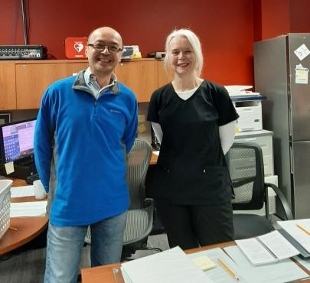 Congratulations to…….
Elaine Doyle, who just passed her game directors’ exam. Elaine is shown here job shadowing with Mike Peng. Please welcome Elaine warmly, as we need all the game directors we can get! (By the way, Elaine doubles as our librarian, and she wants you to know that she needs more bridge book donations for our collection. Enough said.)
--------------------------------------------------------------------------------------------------------------------------------------------

Complaint from Penske 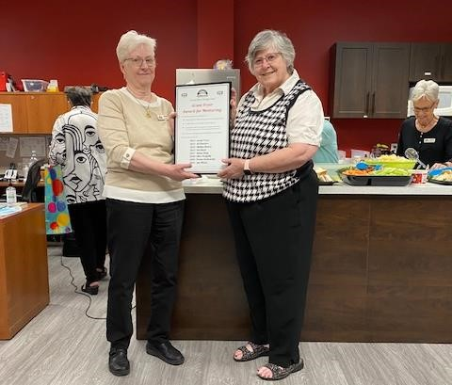 Mentor of the Year
We try very hard to be good neighbours to Penske and we really don’t like it when we get complaints. The latest is that one of our players was observed smoking at the front of the building by our shared entrance. Penske really doesn’t like this.
If you are a smoker, please patronize the designated smoking area at the back by the picnic tables. You can get there via our back door (off the corridor to our teaching room).
--------------------------------------------------------------------------------------------------------------------------------------------
Our players have spoken! They were asked to vote for their favourite mentor, and this year’s winner is Sue Moses - the teacher of our beginners’ lessons and the organizer of our bridge labs. In the photo, Joan Slover (membership lead) is presenting Sue with the plaque – which will hang on the wall near our entrance. Sue was really surprised and touched, even kind of mistyeyed. Our volunteers really appreciate appreciation!
--------------------------------------------------------------------------------------------------------------------------------------------
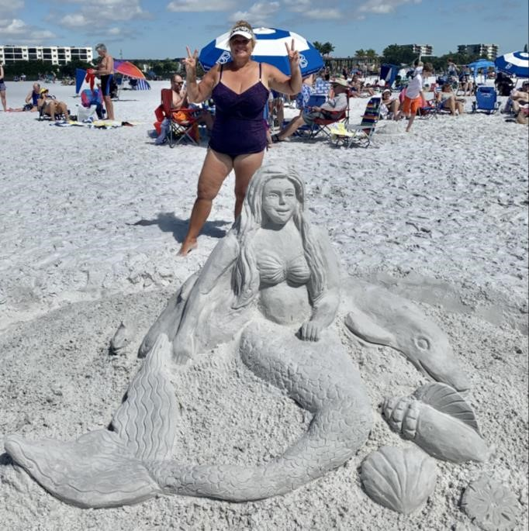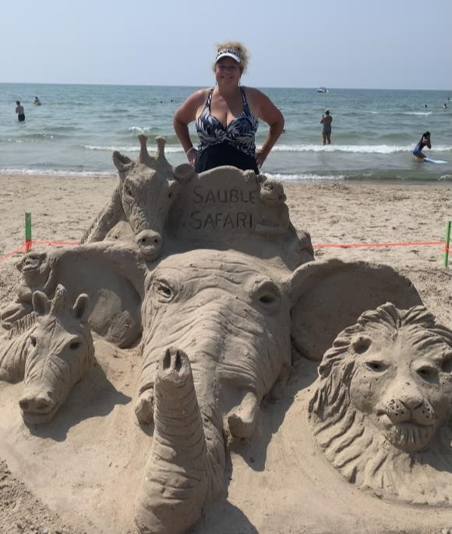

Contributed by Louise Dawdy
This week we are introducing new member Sharon Nesbitt.
Sharon started playing bridge at age 13 with her mother, aunt, and grandmother. It was just kitchen bridge with very few conventions and she always had a cheat sheet beside her. Fast forward 40 years and Sharon started playing again once a week with her mother. They played duplicate bridge together at a non-sanctioned club, and when her mom would take lessons, she would pass all the lesson info along to Sharon.
In 2019, after her mom’s passing, Sharon stopped playing in-person bridge altogether, but would occasionally play online. Then when Sharon and her husband, Brian, moved to Waterloo from Listowel two years ago to be closer to their grandkids, she decided to take up in person bridge again and found GRBC through an online search.
Sharon is also a busy granny of three boys (aged three, two-and-a-half, and one), with #4 on the way (maybe a girl this time??). She does a lot of babysitting and loves every minute of it! Sharon shares her love of family and bridge with a passion for building sand sculptures. Sharon spends her summers at Sauble Beach as well as a couple of winter months in Florida where she builds sand sculptures to her heart’s content. She feels lucky to have a husband that puts up with her obsession with playing in the sand. In fact, Sharon is such an amazing sand sculpture designer/builder that she was featured on the TV show Race Against the Tide on CBC (first season) as one of the Sand Grannies!!!)
The most important lesson that Sharon has learned since starting back at duplicate bridge is that still has a lot to learn. She says that her partners have all been very forgiving and her opponents very kind.
--------------------------------------------------------------------------------------------------------------------------------------------
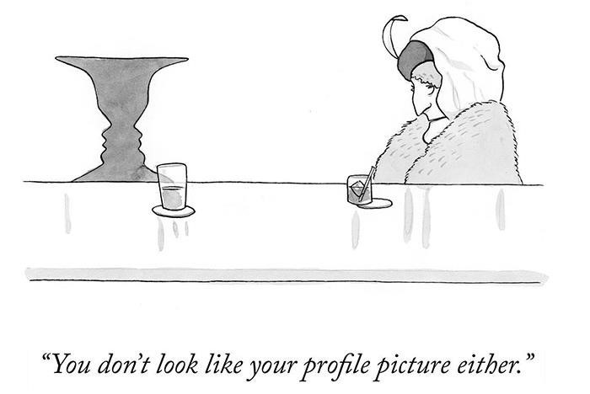
The Common Game: See How Well You Did in a Very Large Group of Players!

Happily, all GRBC online BBO games use The Common Game hands. These same hands are played across North America by many clubs at approximately the same time. Often more than 500 pairs play the same hands as you. Then The Common Game takes the raw data for each hand and recalculates your score, as if all those tables were playing in the same room.
So, is it easy to find out your score in this big field? Yes, just one click!
You will get an email from The Common Game about three hours after the game. Click on the link named “Personal Common Game Home Page”. You will see a page like this.
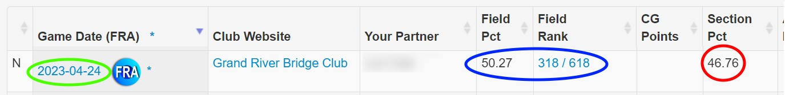
The Section % is what was calculated in your club game. The Field % is what has been recalculated in the big Common Game virtual room with hundreds of tables. In this example with 618 pairs, our Field % rose by 3.5%.
Looking at your performance in The Common Game lets you know how well you are really doing.
Maybe even help you get ready for a Regional where you might actually have all those tables! How can I receive my emailed results from The Common Game immediately following the game?
Players who have their email addresses registered with the ACBL will automatically have their results emailed to them after the game. If you do not have your email address registered with the ACBL, you can enroll by emailing your ACBL # (typed in subject line, no need for any message in the body of the email) to FastResultsHelpDesk@gmail.com.
Once you've done this, you will start to receive emailed results after the game. If you do not see emailed results, be sure to check your spam folder as results often get stuck in the spam folder.
If you have any issues signing up, please contact help@TheCommonGame.com.
--------------------------------------------------------------------------------------------------------------------------------------------
Baby Giraffe Smile

The Bean Counter
Contributed by Steve Allen, Treasurer
Ever wonder why GRBC charges more for some games? For example, the recent “Silver Linings” cost online players an extra $2US to play. The “ACBL Charity Foundation Games” earlier this month cost F2F players an extra $2CDN. It is not enough to remortgage your house, but still … gosh golly … that’s the price of a coffee…
It’s not a mystery that requires the services of Sherlock Holmes or his brother, Mike. These are special ACBL events where the lure of special coloured master points apparently demands that they charge us extra. We just pass this cost along to you.
--------------------------------------------------------------------------------------------------------------------------------

When Your Mail Program Insults Our Club by Classifying Our ALERTs as “Junk” or “Spam”
Unfortunately, there is nothing that the sender (us/GRBC/Pianola) can do to fix it – it is an issue with the receiver’s email system.
Individual users, on the other hand, should be able to fix it by taking the following steps.
- Find a copy of the ALERT in your SPAM/Junk/Bulk Mail folder
- Right-click on the ALERT email – you should see a menu of options, one of which is something like (different email systems use different words for this): o Classify this email as “Not Junk” o Trust email from this sender o Trust emails from this sender’s domain o Never block emails from this sender
o Never block emails from this sender’s domain
- If you click on one of these options, future ALERTs should thereafter just go into your regular Inbox
Another good practice to prevent emails accidentally going to SPAM is to add the sender's email address to your contacts. In this case, you would make sure you add the Grand River Bridge Club to your contacts with the email address GrandRiverBridgeClubManager@gmail.com. Please note that this sender email address has changed.
-------------------------------------------------------------------------------------------------------------------------------
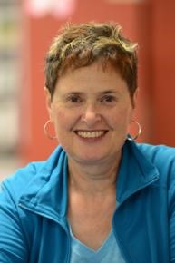 The Answer Lady
Contributed by Susan Lawton

As the “The Answer Lady” I have been responding to questions from “newer” players over the past several weeks. A request has been made to share those players’ questions and my responses in the Alert, essentially a column for the beginner player! You can write to me at suzan2420@yahoo.ca. I have a “small” library of prepared questions, but I would welcome additional questions to build up that library and keep this column viable.

Question
I am never certain how I should proceed after the opponents open the bidding with a pre-emptive (weak two or weak three) bid. I usually feel the urge to bid and compete especially since their opening bid shows a weak hand, and I invariably end up in trouble, either going down or on occasion missing a game contract. A case in point is the hand below. East opened the bidding in first seat with a weak 2 bid. I was sitting in South and decided to bid 3♦, West furthered his partner’s pre-empt with a 3 bid, and my partner placed the final contract in 4♦. Down we went, subsequently receiving a bottom board for our efforts.
Answer Lady, what went wrong? How can I improve my bidding over pre-emptive bids? Are there specific guidelines for competing after weak two and weak three opening bids by opponents?
Signed, an overwhelmed player

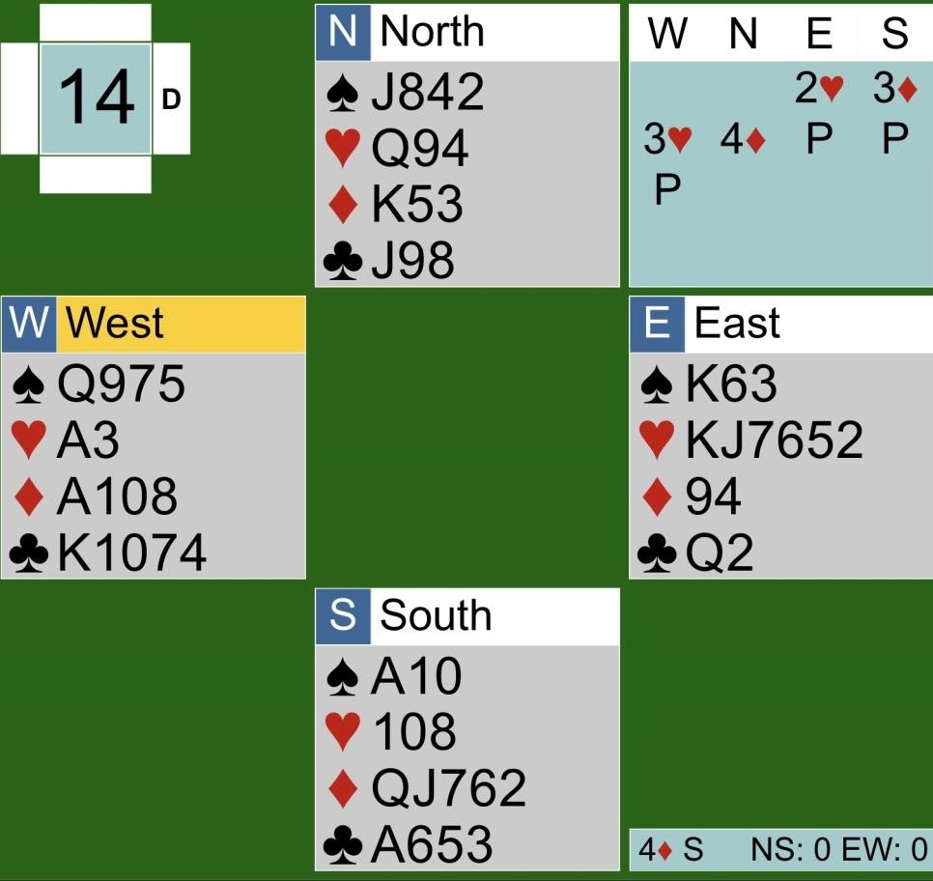
Thank you overwhelmed player for sharing this hand and posing these interesting questions. Rest assured we all have been there. The opponents open pre-emptively and we feel compelled to bid. That pre-emptive bid has done what it was intended to do: disrupt the bidding. The key here is you are not required to bid after an opponent pre-empts yet you have less than opening points in your hand. Just let the bidding continue. Your partner still has a bid and may have enough values to think about competing.

There are a lots of online and in-print strategies on how to compete in these types of auctions. Several years ago, I was fortunate to attend a class taught by Liz McDowell that handled this exact topic. Liz provided us with simple, straightforward, and effective strategies that I share today.
Liz's strategies reformatted by the Answer Lady
- With an opening hand, bid your five-card suit. I would like to add that you should have a good five-card suit.
- Double if you have opening points, no five-card suit, and tolerance for the other suits. This is essentially a take-out or power double. Partner will show values by bidding their best suit and at a level to show their hand values. Partner is secure in the knowledge that you have an opening hand and game might be a possibility.
- Bid 2NT if you have 15-17 points and stoppers in the pre-empted suit. You would have opened this hand in 1NT if the opponents hadn't bid. With partnership agreement, systems are on and your partner can use Jacoby Transfers and Stayman to find a fit.
- Double, and then after partner's response bid 3NT with 20 or more points and stoppers in the opponents’ suit.
- DON'T pre-empt a pre-empt.

On reflecting on your hand, you do not meet any of the bidding requirements from the listing above. Yes, you have a five-card suit in diamonds, but that suit is headed by only the queen and jack. In addition, you have only 11 points, not opening values. The preferred bid here would be a pass. You are not compelled to bid. That 3♦ bid emboldened your partner who was anticipating a stronger hand than you actually held. The player with the strongest hand in this auction was actually West who had an opening hand. They recognized partner's bid for what it was and made a simple raise.

I hope these strategies help you refine your bidding after you encounter a weak opening bid from your opponents.
--------------------------------------------------------------------------------------------------------------------------------
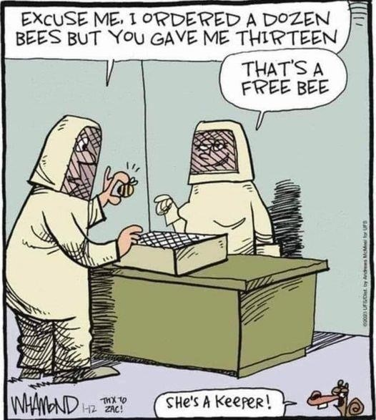
A Honey of a Deal
TIme You Learned our Lessons!

Our Bridge Labs
Every Monday morning (except holiday Mondays), newer players are invited to our club to play hands but not keep score. These sessions are very informal and relaxed.
At our bridge labs, you can discuss the hands witih and ask questions of the experienced lab leader(s) present. You don’t need to pre-register, come with a partner, or even arrive on time. This is an excellent way for beginner/novice players to learn the ropes and improve their skills.
SPECIAL ATTRACTION
On Monday, June 5 and Monday, June 19, the Answer Lady (Susan Lawton) will be teaching mini-lessons on opening leads from 9:00 am – 9:30 am and then giving the players pre-dealt hands to practice the new learning.

Cost: $8 members/ $10 non-members
--------------------------------------------------------------------------------------------------------------------------------------------
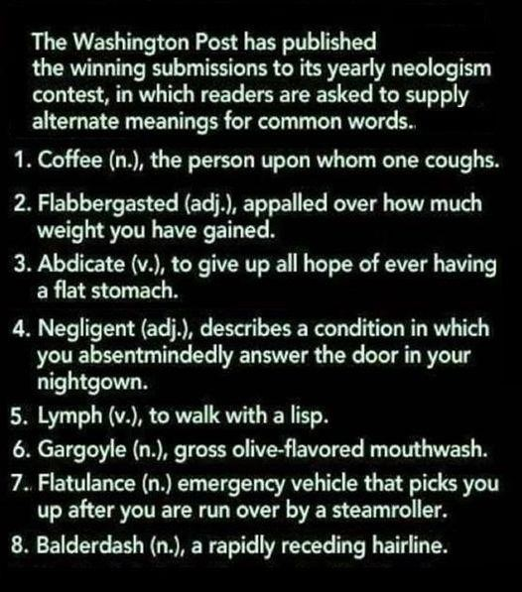

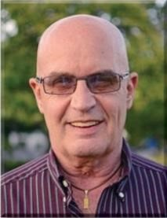 Dear David

All Your Chances, Revisited

Bridge experts will frequently remind you that when you are declarer, you should pause to make a plan at Trick 1 after the opening lead is made and the dummy has been revealed. Sometimes the plan is simple. Sometimes it is very complicated because there are a multitude of options to choose from. The trick is to choose an option that allows you to take advantage of all your chances to be successful.
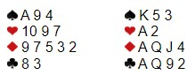
East opens 2NT and West is left with a tough choice as to whether to try for game with only one sure trick. Since it is possible that East has a five-card major, in which case four of a major might be a viable contract, West tries 3♣ (Puppet Stayman, asking for a four- or five-card major) and East says 3NT because he has neither. South leads the ♠Q. If you assume diamonds are not splitting 4-0, you can win the first spade, play the ace and queen of diamonds, win the spade return, finish the diamonds, and lead a club from the West hand hoping the club king is held by North. Two spades, one heart, four diamonds and two clubs adds up to nine tricks. Is there any thing better than the 50% chance that the ♣K is in the North hand? My partner mistakenly thought that he needed to keep the ♠A in dummy as a late entry for the club finesse, but further reflection should reveal that the ♦4 will be an entry to the dummy after the ♦K is knocked out. Therefore, you can use your ♠A at Trick 1 to try the diamond finesse. If North has Kx of diamonds, you have five diamond tricks. You can try the club finesse for an overtrick after you finish the diamonds.
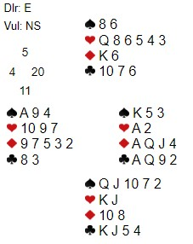
My partner won the ♠K and played the AQ of diamonds. At that point, nine tricks became impossible. You will find that most of the hands you declare will have multiple chances of success - so long as you take the time to imagine them at Trick 1.

Top Master Point Earners at our Club Contributed by Allen Pengelly

This table lists the individuals who have earned the most master points at our club in each of three master point bands since the beginning of April.

Open Players
Name MP
- David Baker 18.33
- Cindy Mahn 15.48
- John Hanemaayer 10.60
- Ted Boyd 9.68
- Mike Peng 8.99
- Edith Ferber 8.60
- Colin Harrington 7.95 8 Moira Hollingsworth 7.01
9 Malkin Howes 6.35 9 Stephen Young 6.35 11 Robert Griffiths 6.27 12 Dave Quarrie 6.07 13 Kathy Russell 6.01 14 Liz McDowell 5.59
- Paul Latimer 5.22
- Neil Jeffrey 4.91 17 Diane Jamieson 4.88
18 Sandy Graham 4.63 19 Dianne Aves 4.58 20 Adriaan Kempe 4.52 21 Sharon Boyd 4.49
22 Scott Hills 4.39 23 Mary McClelland 4.39
- Larry Woods 4.08
- Ron VanDerZwaag 4.05
499er Players 99er Players
Name MP Name MP
1 Barbara Arthur 10.48 1 Rick Arthur 5.30 2 Suzanne Edwards 8.20 2 Peter Gaasenbeek 4.78
  - Shelley Metcalfe 7.63 3 Debbie Miethig 4.51
  - Salvatore Pace 7.17 4 Sharon Nesbitt 4.13
  - Andy Martinek 6.74 5 Alicia Wright 3.65
  - Lori Cole 6.15 6 Audrey Cook 3.07
  - Nancy Cattanach 5.98 7 Jim Fox 2.24
  - Noah Pace 5.69 8 Louise Dawdy 2.21
  - Martin Jones 5.62 9 Pat Pietrek 2.16
  - Jim Dalgliesh 5.56 10 Pat Gascho 2.15
  - Sue Moses 5.54 11 Peggi Rieger 2.13
  - Lynda Burnett 5.42 12 Susan Murray 2.02
  - Steven Allen 5.39 12 Ellen Libertini 2.02
  - Brenda Semple 5.17 13 Doug Livesey 1.85
  - Renate Boucher 4.91 15 Jane Wilson 1.84
  - Joan Slover 4.78 16 Larry Brooks 1.82
  - Jack Cole 4.77 17 Don O’Bright 1.69
  - Nanci Phelan 4.54 17 Richard Wehrle 1.69
  - Judy Beauchamp 4.48 19 Dona Reinhart 1.62
  - Molly Worden 4.25 19 Carolyn Israel 1.62
  - Barbara Lindsay 4.15 21 Randall DeKraker 1.56
  - Bob Giilck 3.89 22 Ruthanne Erwin 1.54
  - Bev Hitchman 3.67 23 Stu Cowan 1.52
  - Cheryl White 3.54 24 Ronnie Lowrey 1.46
  - Andy Wilson 3.46 25 Russel Kerr 1.39

-------------------------------------------------------------------------------------------------------------------------------------------

If you would like to play in a particular game but lack a partner that day, you can either:
  - For both online and f2f games, log on to Pianola, click on Partner Finder, and create a Partner Finder advert. This needs to be done at least a few hours in advance of the game.
  - For online games only, log in to the game in question and register yourself on the Partnership Desk tab.
If you are looking for a regular partner, contact Joan Slover, our membership lead.

We have fun in spades.
We play with all our hearts.
We treat our members like diamonds.
Barbara Seagram wowed our club.

