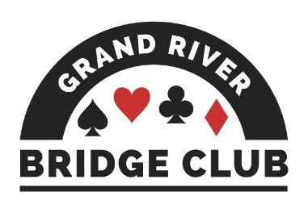PLAY AND LEARN BRIDGE IN A WELCOMING ENVIRONMENT245

ALERT – May 29, 2023

Click here to access our regular game schedule.

Looking Ahead

 Our two F2F games on Friday, May 26 will be club championship games (extra masterpoints, no extra cost).
 The 499er F2F game on Thursday afternoons has been cancelled effective June 1.
 Spring Niagara-on-the-Lake Sectional, June 2-4, 0-750 tournament
 Sarnia Local Sectional, June 3-4
 June 5-11 will be NAP games at our club (red/black points, extra $2) for all open and 499er games, both F2F and online. The Thursday evening game will be a 2499er game in order to be eligible to be an NAP game.
 The F2F games during the week of June 19 will be club championship games = extra masterpoints, no extra cost).
 It will be Volunteer Appreciation Day on Tuesday, June 20, with a potluck lunch and both an open and a 199er game in the afternoon.

--------------------------------------------------------------------------------------------------------------------------------------------

Thursday F2F 499er Game - Cancelled Effective June 1
We haven't been consistently getting enough 499ers to run a separate section, so the game is cancelled effective June 1. However, that shouldn't stop 499ers from coming out on Thursday afternoons. The 499ers have been holding their own in the Open game - just ask Suzanne Edwards and Barbara Arthur who won a recent Thursday game. Not only is it a fun afternoon with nice people, you can also get free tips to improve your game (but only if you ask)!
--------------------------------------------------------------------------------------------------------------------------------------------

Mark your Calendars!
- To honour all of our wonderful volunteers at GRBC, we will be holding an Appreciation Day on Tuesday, June 20.
- We will be celebrating with a potluck lunch at 11:45 am followed by a two-section game,
199er’s and open.
- The 2022 Mini-McKenney and Ace of Clubs awards will be presented by Ted Boyd.
- Sign-up sheets for registration and the potluck lunch will be on the magnetic bulletin board near the director’s desk.
- Hope to see you all there!
--------------------------------------------------------------------------------------------------------------------------------------------
Our Club’s Management Team
Although (hopefully) our club appears to operate smoothly and effortlessly – you know, you show up for a game and it runs and you have fun; you show up for your lesson and your teacher appears and you learn a lot – in fact it takes a huge amount of work behind the scenes to make it appear so effortless. And virtually all of this work is performed by volunteers.

This is the fifth in a series profiling the current members of our club’s management team and thanking them and their predecessors for their stellar work. Next up is our manager, Doug Grant.

Before we tell you about Doug, however, we need to thank and praise his predecessor, Jim Dalgliesh. For more than eight years, Jim was the “go to” guy for almost everything at our club and, if he couldn’t answer a question directly, he knew where to re-direct the enquiry. Congenial and low-key, Jim was and is a supporter and promoter of the club through its early development and three location changes. In characteristic Jim fashion, he committed to assisting the person who took over the manager position, Doug Grant.

Doug answered our questions as follows.
Describe what your current volunteer position entails, maybe a paragraph or so. As manager, I chair the Management Team, which is responsible for most areas of club operation except for the games themselves.
Tell about how you got interested in bridge and your early playing experiences. I first learned bridge as an undergraduate at Acadia in the mid-60's and was intrigued by its mathematical structure. I played only occasionally (and very badly) until 1979, when I got a serious partner while on sabbatical in Connecticut. Regular play was again put on hold while two children were raised, but became more serious when another player joined my department at the university in Sydney. After retirement in 2010, my late wife Kathy and I played together in K/W and area until Covid descended. After her passing in 2021, I have played with four other regular partners, and occasional others.

Outline your background, your hobbies, etc.
I grew up in Cape Breton and attended Acadia and Syracuse universities before receiving a Ph.D. in Math from McMaster in 1971. I taught at Cape Breton University in Sydney, NS, for 38 years, retiring as Emeritus Professor in 2010. I began a second career as an independent financial advisor in KW, building on a textbook in financial math written while at CBU. I have travelled to 41 countries, with a focus on archaeology. I also have done extensive genealogical research, and am planning a historical novel based on some of that work. I am active in the Retreads hiking group, and regularly attend Stratford, the Shaw, opera, and foreign films. More recently, I have joined New Beginnings, a meet-up group for widows and widowers.

Give your favourite bridge tip.
If you now play DONT, please stop. If you haven't adopted DONT, please avoid it. SANTA offers a more precise and ethically-respectable defence over NT.

Write down any amusing or insightful anecdotes about playing bridge.
My partner in Connecticut managed to draw cards from the wrong board, and I failed to notice that the colour of his cards did not match my own. The resulting bidding tangle ingrained the habit of ensuring all cards in play at given time do match!
--------------------------------------------------------------------------------------------------------------------------------------------

The GRBC Board needs You!
In preparation for our upcoming Annual General Meeting this September, there are several board vacancies to fill. So, what does the club’s board of directors do?
- According to our club’s bylaw, the board sets the policies and administers the affairs of the club.
- It establishes the committees that carry out the day-to-day activities of the club, both in person and online.
- It is responsible for the financial oversight of the club’s operations.
- Finally, it keeps the membership informed of important developments.
We are a non-profit organization, and we need capable volunteers to step up and help run our club going forward. If you are interested and need more information, please contact a member of our Nominating Committee.
- Mike Peng (michael.peng@rogers.com) or
- Mary McClelland (mjm4bridge@gmail.com) or
- Douglass Grant (douglass_grant@cbu.ca).
--------------------------------------------------------------------------------------------------------------------------------------------

Congratulations to the following local players who were in the money at the CBF regional tournament in Niagara Falls.
- Scott Hills and Neil Jeffrey, 4th in B, Monday Open Pairs
- Diane Bourdeau, Edith Ferber, Margot Stockie, and William Christian, 2nd in A, Monday Brk Teams-1
- Sharon King, Moira Hollingsworth, Marlene Benny, and Bruce Roberts, 2nd, Tuesday Brk Teams-1
- Karen Whitworth and Marylynn Benjamins, 3rd in A, Tuesday Super GR Pairs
- Andy Wilson and William Sherman, 2/3, Thursday Gold Rush Pairs
------------------------------------------------------------------------------------------------------------------------------------------
We Want More Tables at our GRBC Online BBO Games!
Yes, we all prefer to play in a larger field as some of you mentioned on your survey. Lately, our BBO table counts have been dropping. So GRBC is working on multiple ways to grow our BBO game attendance.
- We are encouraging more visitors to come play at our club and you can help! Please also invite your non-GRBC friends to play with you at our club. As long as you do the inviting on BBO, they will not even count in our weekly visitor quota.
- Survey: Did you send us your thoughts? We are using your survey feedback to figure out the best online BBO game offerings and schedule from now until the cold weather comes back. The survey takes less than five minutes to fill out, so if you have not done it yet now is your chance. Click here for the survey.
- We are working to “pool” our approved online player list with more Ontario clubs. This means that many more club players will automatically know about our online games, and be immediately eligible to play in them, without requesting permission.
- We will be working with the ACBL to update our approved player list.
- We are planning some online activities to enhance our BBO attendance.
Details about these and more will follow in the coming weeks!
--------------------------------------------------------------------------------------------------------------------------------------------
The Bean Counter
Contributed by Steve Allen, Treasurer
If you made it out to the Barbara Seagram event on May 3, you were treated to a fantastic time. Making this happen was not the work of elves in the middle of the preceding night. It came about by many hours of volunteer work. In this case, the elves were Anita Hanson, Debbie Miethig, Barb Neibert, and Audrey Cook. Just look at their pointed ears for proof.
The event consisted of a bridge lesson from BS herself in the morning, lunch, and a duplicate bridge game (18 tables) in the afternoon. Congratulations to Louise Dawdy and Cheryl White who came first overall. Barb Seagram came first in her section, but maybe our ineptitude was purposeful to ensure that she comes back some day. ☺
Seventy-seven people (members and non-members) paid $35 each to attend the event, and we made a profit of $1364,
Hopefully, online GRBC players and non-members experienced how much fun playing bridge at our clubhouse can be and how safe it is. We know the regular F2F’ers did.
Aside: apparently, Barbara reads our ALERT every week and is delighted with the Bean Counter articles. She wants to be the first president of the Bridge Bean Fan Club.
--------------------------------------------------------------------------------------------------------------------------------
Roy Dandyk Member Profile
Contributed by Louise Dawdy
This week we are highlighting GRBC member Roy Dandyk. Roy started playing bridge in high school and then again in his early 30s. Both times Roy played for about five years. He started up again about ten years ago.
Roy is a sports enthusiast, playing basketball competitively into his late 50s. He continues to run the KW Men’s League today. Roy also competed in football and soccer as well as badminton in his youth and early adulthood.
Roy’s favourite sports teams are Bayern Munich (soccer), and Gonzaga Bulldogs (basketball).
Roy’s best bridge tip is: “When you have a good hand, take your time to get to the best contract. When you want to disrupt the opponents, get to your contract as soon as possible, but watch the vulnerability.”
With regard to duplicate bridge, Roy thinks competition is great, but that it is important to always (!!!) be kind to your partner as well as your opponents!!!
Post-pandemic highlights for Roy are the return of F2F bridge as well as travel.
Roy is currently planning a three- or four-month vacation/trip that will take him to Hawaii, Fiji, Australia, and New Zealand.
--------------------------------------------------------------------------------------------------------------------------------
Changes to the Alert Procedures
A couple of years ago, the ACBL made a bunch of changes to its Alert procedure. These changes are reflected in the ACBL’s new convention cards, but unfortunately our club is still using up its old convention cards (we have a lot of them left). That means that you can’t always use our convention cards to see what’s alertable (things printed in red).

The most common calls that have had their Alertability changed are as follows.
- In an uncontested auction, no natural jump shift (whether weak, intermediate, or strong) requires an Alert.
- A direct cuebid that is not Michaels (showing both majors over a minor, or a major and an unspecified minor over a major) now requires an Alert.
- Support doubles and redoubles no longer require an Alert.
- Puppet Stayman no longer requires an Alert, although follow-up bids do require an Alert.

If you are not sure whether to Alert a call, err on the side of Alerting it.
- There is absolutely no downside when it comes to online games since your partner can’t see your Alerts.
- There is a slight downside for F2F games given that your Alert may “wake your partner up” – but this is not likely a disadvantage for the players at our club since we are all completely au fait with all of our conventional agreements with all of our partners. ☺

For a fuller treatment of the main changes to the Alert procedures, click here.
--------------------------------------------------------------------------------------------------------------------------------

The Answer Lady
Contributed by Susan Lawton

As the “The Answer Lady” I have been responding to questions from “newer” players over the past several weeks. A request has been made to share those players’ questions and my responses in the Alert, essentially a column for the beginner player! You can write to me at suzan2420@yahoo.ca. I have a “small” library of prepared questions, but I would welcome additional questions to build up that library and keep this column viable.

Question
In a recent GRBC 199 game, my partner and I played this hand and failed to get to game. Other pairs played the hand in 3, 3NT, and 4. Where did we go wrong? It went pass pass pass to me sitting in the West seat, and I opened 1. North passed, and then my partner responded 1NT.
Can I assume that I am not expected to bid over my partner’s response of 1NT? Or perhaps I am allowed another bid? How were other pairs successful in bidding to 4 and 3NT? Thank you for help, Answer Lady. Signed, a confused 199 game player

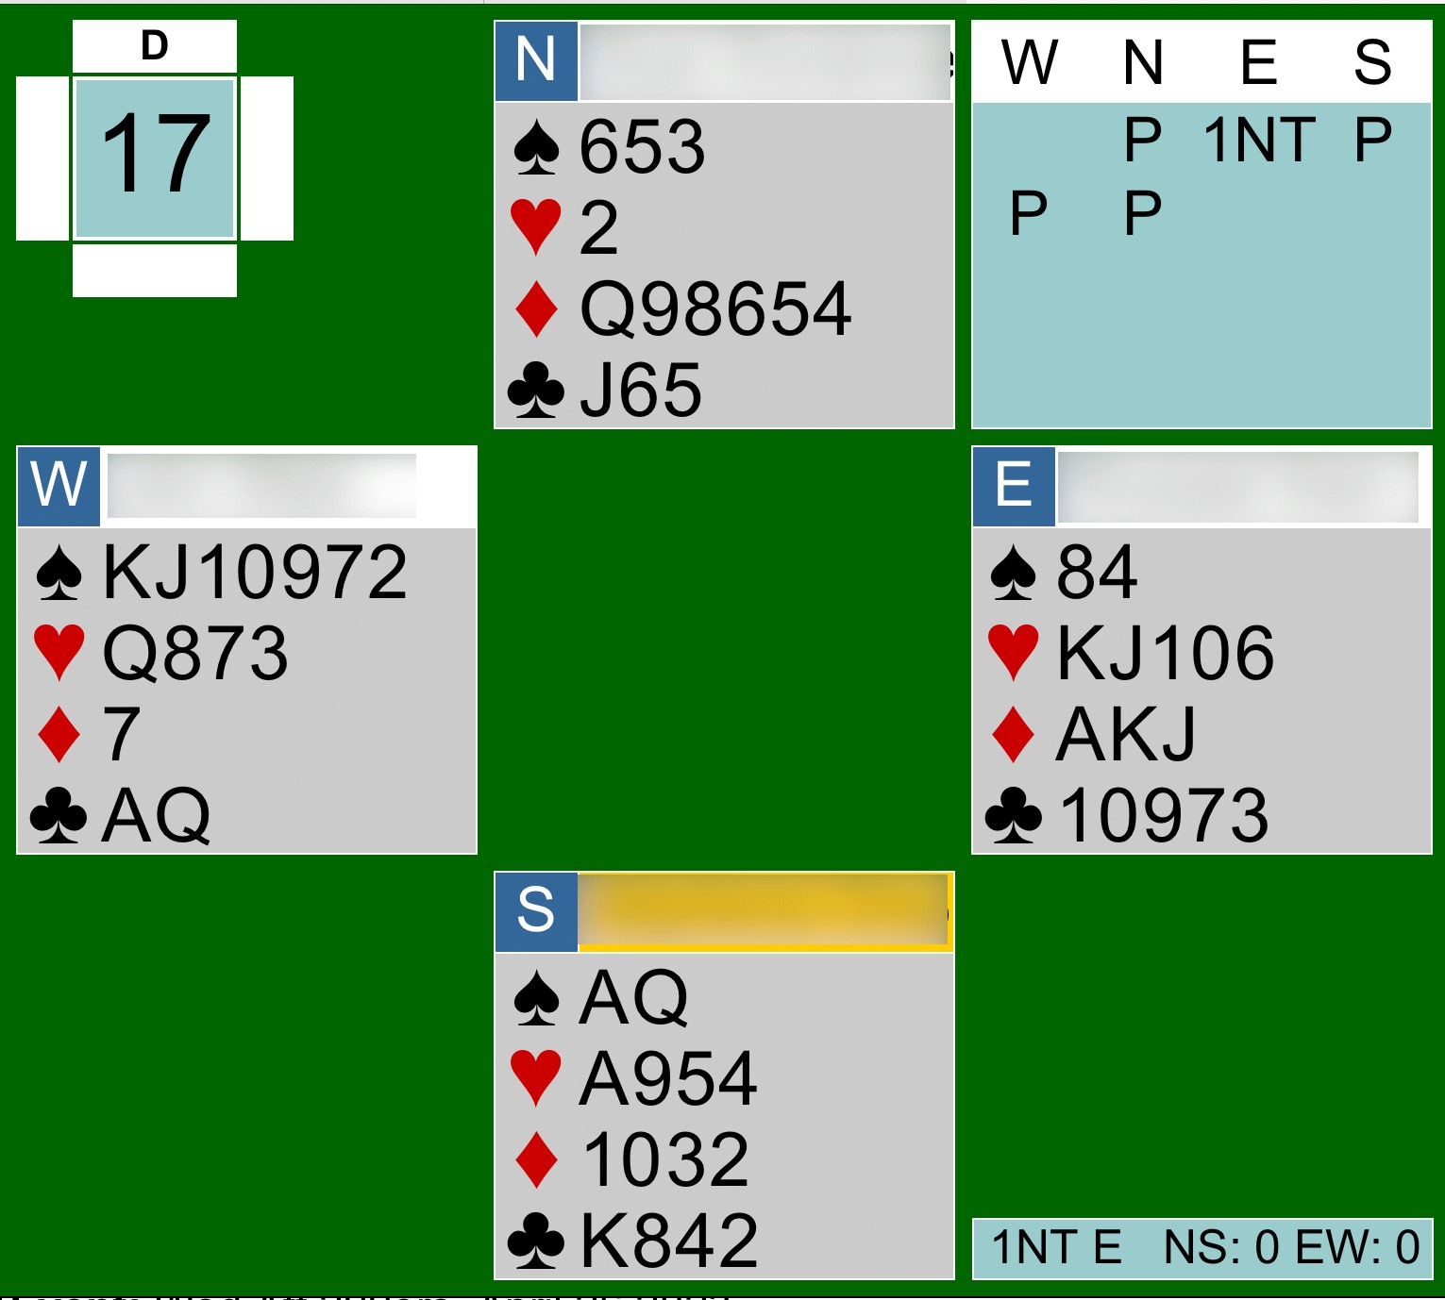
Dear confused 199 game player, thank you for sharing this hand. I can certainly understand why you were confused and it likely impacted your ability to reach the right contract. I have to say the Answer Lady was also confused by the bidding.

Unfortunately, the hand diagram doesn’t allow us to see the complete bidding on this hand, only the final contract. Let's review how the bidding evolved. North had the first opportunity to bid and with three points wisely chose to pass. Next up was your partner, East, who with 12 points could have bid but decided to pass. Then South with 13 points should have opened the bidding but also passed. You in West, with 12 points and a solid six-card spade suit, opened 1. North passed and your partner bid 1NT. This was the final contract and you made 3NT.

That 1NT bid doesn't truly reflect the strength of East's hand - 12 points. A 1NT response is usually reserved for poor support in spades and six-nine points. You are correct in assuming that once your partner bids 1NT, that is a non-forcing bid and you can pass. With six spades, however, you can repeat those spades by bidding 2 even after your partner limits their hand by bidding 1NT.

As mentioned, East’s hand is too strong for 1NT, meaning that they need to make a temporizing bid at the two-level, likely 2♣. (They can't bid 2 as that bid would promise five hearts.) But East should now be very interested in game given his almost-opening hand facing an opening hand. Over 2♣, you could repeat your spades, promising six spades, and your partner could now bid 3 to show four hearts, allowing you to find the 4 game. As you discovered, a 3NT game would also be successful.

That said, I think East could open that hand with 12 points by starting the bidding with 1♣. If East doesn't open the bidding, for sure South should open with 1♣ and 13 points (it is not clear to me why they chose to pass), It is more effective and easier to bid when you know how many points your partner has - and that much harder when the opponents muddy the waters.
--------------------------------------------------------------------------------------------------------------------------------
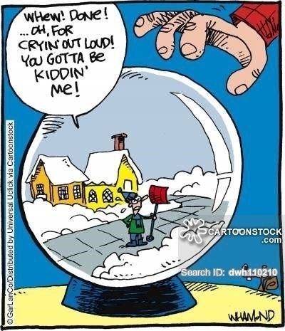

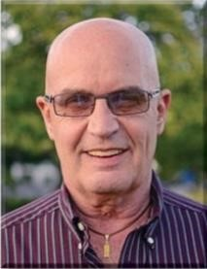 Dear David

The Resurrection

We have all suffered with the pain of bidding RKC Blackwood on a hand that seemed destined to produce a small slam or even a grand slam, only to find out that two keycards are missing. Today’s hand is representative of another facet of that dilemma.

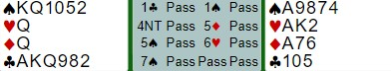

West gets very excited when he starts with his longest suit (recommended) and East shows a four-or-more-card spade suit. All he needs is a couple of aces to make a spade slam a good prospect. Imagine his despair when partner bids 5♦, showing zero or three keycards. Since his precipitous jump to 4NT robbed East of any chance of showing the true strength of his hand, he had to stop in 5♠ in case partner had no keycards. Here is an answer to that problem.
If partner responds 5♦ (zero or three keycards) and it’s possible from the bidding that partner could have either zero or three, you should assume he has no keycards and sign off. Perhaps responder’s hand looks something like this: ♠J9874 ♥KJ2 ♦K76 ♣105. The same is true for a 5♣ response (one or four keycards). Sign off if partner could have only one keycard.
From the other side of the table, if you have three or four keycards you should assume you belong in slam. It would be a rare day when you had three keycards and partner jumped all the way to 4NT with no keycards! So how do you proceed with three or four keycards?
You bid as if partner had bid 5NT, asking for kings. If you play 5NT asks for the number of kings, show the number of Kings (6♣=0, 6♦=1, etc.). If you play 5NT asks you to show your cheapest side King (as we play on this hand), show the king. My 6♥ bid completes the picture – three keycards and the king of hearts. An excellent grand slam. Barring a ruff of the opening lead, this one is a claimer.
Curiously, the hand was played five times: 6♠ at four tables and 6NT at the fifth table. Yes, my partner had a brain cramp and bid only 6♠. Perhaps I should bid 7♠ after partner signs off in 6♠, because he must have a hand that looks a lot like this for his jump to 4NT. Good partnership management involves sucking up some of the blame, even when you don’t think you deserve it.

--------------------------------------------------------------------------------------------------------------------------------
No. 113

♠ AQ4
♥ AK
♦ 4Jake
♣ 8765432

♠ KJ
♥ Q109652
♦ A10762
♣ #113
West | North East | South
 |  | 1♥
2♦ | 3♦ Pass | 3♥
Pass | 4NT Pass | 6♣1
Pass | 7♥ Pass | Pass
Dbl | All pass

1. Odd number of keycards and a void in clubs

My partner and I weren’t on the same page in the bidding, but it was no wonder since we really shouldn’t have been using Blackwood with a void in one of the hands. As a result, we got too high and the opponents doubled us.

The ♦K was led by West and I took it with my ♦A, East following suit. If you were in my shoes, what would you do now?

SOLUTION

If you use your own hand as the master hand (the usual way), even if you ruff two diamonds in dummy (using up two top hearts), you still have two diamond losers left to deal with. Plus, now you figure to lose a trick to the ♥J. Not the way to go.

What about thinking outside the box and using the dummy as the master hand (as if you are sitting North)? Now count your losers. Your only problem suit is clubs, but it may be possible to continually ruff clubs until the suit is established. In order to do this, you are going to need dummy entries, the number of which will depend on how the opponents’ clubs split. (This is a case of you can’t be too thin or too rich or have too many dummy entries.)

On this hand, you have exactly four dummy entries in the dummy - two in spades and two in hearts. So, you need to hope that the opponents’ clubs split three-three, allowing you to establish the suit in three ruffs and then use dummy’s fourth entry to get back to cash the established clubs. You will also need a friendly trump distribution (3-2). Obviously, this is a slim hope, but it is your only hope.

So, at Trick 2, enter dummy with a trump and at Trick 3 ruff a club in your hand. Rinse and repeat at Tricks 4 and 5. Now you know the opponents’ trumps split three-two. So far so good.

At Trick 6, play the ♥Q to draw the last outstanding trump, discarding the ♠4 from dummy.

At Trick 7, lead the ♠K and overtake it with the ♠A! Then ruff another club with your last trump and cross your fingers that both opponents follow suit. They do!

Now, go back to dummy with the ♠Q and use the established good clubs to take care of your hand’s losing diamonds.

Here is the full hand.

♠ AQ4
♥ AK
♦ 4Jake
♣ 8765432
♠ 8 ♠ 10976532
♥ J43 ♥ 87
♦ KQ9843 ♦ 5#113
♣ AKQ ♣ J109
♠ KJ
♥ Q109652
♦ A10762
♣ #113

Never underestimate the power of a seven-card suit, even one with no high cards.
--------------------------------------------------------------------------------------------------------------------------------
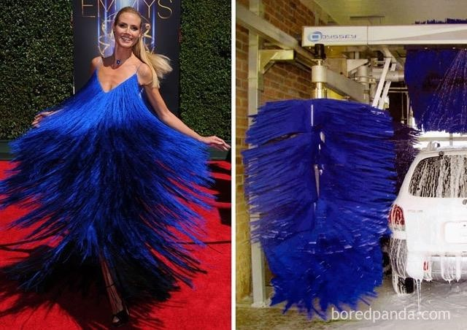
Who Wore It Better?
Top Master Point Earners at our Club Contributed by Allen Pengelly

This table lists the individuals who have earned the most master points at our club in each of three master point bands since the beginning of April.

Open Players 499er Players 99er Players
Name MP Name MP Name MP
1 David Baker 30.69 1 Barbara Arthur 16.15 1 Rick Arthur 6.95 2 Cindy Mahn 21.68 2 Suzanne Edwards 15.62 2 Sharon Nesbitt 6.75
- Ted Boyd 17.14 3 Shelley Metcalfe 12.26 3 Debbie Miethig 6.56
- Mike Peng 15.76 4 Jim Dalgliesh 10.82 4 Peter Gaasenbeek 5.63
- Neil Jeffrey 14.84 5 Joan Slover 10.07 5 Audrey Cook 5.47
- Moira Hollingsworth 14.26 6 Lori Cole 9.42 6 Louise Dawdy 4.52
- Edith Ferber 13.93 7 Sue Moses 8.57 7 Alicia Wright 3.65 8 Colin Harrington 13.51 8 Nancy Cattanach 8.22 8 Jim Fox 3.53
- John Hanemaayer 11.51 9 Salvatore Pace 8.12 9 Pat Pietrek 3.51
- Stephen Young 10.86 9 Andy Martinek 8.12 10 Peggi Rieger 3.01
- Scott Hills 10.28 11 Brenda Semple 7.86 11 Patricia Gascho 2.99 12 Robert Griffiths 9.42 12 Jack Cole 7.49 12 Jane Wilson 2.72
- Neil Coburn 9.27 13 Steven Allen 7.47 13 Larry Brooks 2.67
- Kathy Russell 9.23 14 Martin Jones 7.42 14 Kathy Chandler 2.62
- Dave Quarrie 8.93 15 Barbara Lindsay 6.87 15 Russel Kerr 2.51
- Malkin Howes 8.58 16 Cheryl White 6.51 16 Ruthanne Erwin 2.34 17 Adriaan Kempe 8.08 17 Noah Pace 6.36 17 Stu Cowan 2.24
- Sharon King 7.71 18 Bev Hitchman 6.35 18 Joan Hartviksen 2.15
- Steve Carpenter 7.27 19 Bob Livermore 6.25 18 Randall DeKraker 2.15
- Wayne Schroeder 7.04 20 Sue McDonald 6.09 20 Steve Cameron 2.13
- Liz McDowell 6.83 21 Lynda Burnett 6.06 21 John Aldridge 2.12
- Diane Jamieson 6.59 22 David Dennis 6.02 22 Casi Zehr 2.11
- Susan Lawton 6.13 23 Elinor Girouard 5.96 23 Susan Murray 2.02 24 Frank Fischer 5.93 24 Nanci Phelan 5.60 23 Ellen Libertini 2.02 25 Paul Latimer 5.89 25 Bob Giilck 5.60 25 Doug Livesey 1.85
-------------------------------------------------------------------------------------------------------------------------------------------

If you would like to play in a particular game but lack a partner that day, you can either:
  - For both online and f2f games, log on to Pianola, click on Partner Finder, and create a Partner Finder advert. This needs to be done at least a few hours in advance of the game.
  - For online games only, log in to the game in question and register yourself on the Partnership Desk tab.
If you are looking for a regular partner, contact Joan Slover, our membership lead.

We have fun in spades.
We play with all our hearts.
We treat our members like diamonds.
We treasure our seven-card suits at our club.

