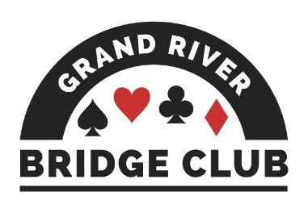PLAY AND LEARN BRIDGE IN A WELCOMING ENVIRONMENT245

ALERT – May 22, 2023

Click here to access our regular game schedule.

Looking Ahead

 Our Saturday afternoon online 199er game is now a 299er game.
 Canadian Bridge Championships, Niagara Falls, May 9 to May 19
 Canadian Bridge Federation Regional, Niagara Falls, May 12 – May 19
 All of our F2F games during the week of May 22 will be club championship games (extra masterpoints, no extra cost).
 There will be no Monday morning bridge lab on May 22.
 Spring Niagara-on-the-Lake Sectional, June 2-4, 0-750 tournament
 Sarnia Local Sectional, June 3-4
 June 5-11 will be NAP games at our club (red/black points, extra $2) for all open and 499er games, both F2F and online. The Thursday evening game will be a 2499er game in order to be eligible to be an NAP game.

--------------------------------------------------------------------------------------------------------------------------------------------

Our July Regional Tournament
This is the first of many many announcements about the regional tournament that our club will be hosting from July 4-9 this summer.
Of course, we hope that you will play early and often at our tournament but – on the days you aren’t playing – please consider offering to be a spare.
Do you like meeting new people? On the days that you are not already playing with a GRBC member, we would love to pair you up with out-of-towners. If you are called upon to spare, you play FREE provided that you are not playing with a member from your own club.
Sign-up sheets with all the necessary information have been posted on the club’s OUR MEMBERS bulletin board. For more information and to volunteer, contact Pat McMillan, pat.mcmillan43@gmail.com.
--------------------------------------------------------------------------------------------------------------------------------------------

Congratulations to the following section winners at the CBF regional tournament in Niagara Falls during the first half of the tournament.
- Adrian Record, Tom Ramsay, Cindy Mahn, and Robert Griffiths, 1st in A, Monday Brk Teams
- Cindy Mahn, Tom Ramsay, Diane Bourdeau, and Edith Ferber, 1st, Tuesday Brk Teams
--------------------------------------------------------------------------------------------------------------------------------------------

Our Club’s Management Team
Although (hopefully) our club appears to operate smoothly and effortlessly – you know, you show up for a game and it runs and you have fun; you show up for your lesson and your teacher appears and you learn a lot – in fact it takes a huge amount of work behind the scenes to make it appear so effortless. And virtually all of this work is performed by volunteers.

This is the fourth in a series profiling the current members of our club’s management team and thanking them and their predecessors for their stellar work. Next up is our membership lead, Joan Slover.

Before we tell you about Joan, however, we need to thank and praise her predecessor, Cheryl
Kip who took over the reins from Ted Boyd about seven years ago when our club was still on Gage Avenue. A “people person”, Cheryl enjoyed meeting newer players and helping them develop their skills through partnerships and mentorship. Membership grew steadily until Covid interfered. At that point Cheryl instituted coaching sessions whereby an experienced player would offer his or her expertise to a group of newer players. They were an instant success and helped many bridge players through those dark years. The organization and administration of these coaching groups required almost superhuman effort, and it is no wonder that as we emerged from the Covid cage, Cheryl was motivated to recruit someone to take over from her, to wit: Joan Slover.

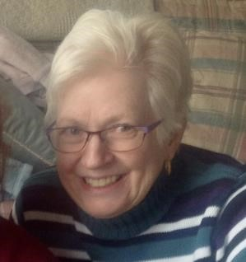 Joan has kindly done her own write-up, so we now bring you our current
membership lead in her own words….

Currently, I am in charge of membership and mentorship. Prior to that I was assistant manager. Back in those days, the only record we had of members was a binder with the paper memberships forms, so I created a spreadsheet. Then came Pianola! Thank goodness.

As membership lead, I add new members to Pianola and follow up with a phone call. I tell them what Pianola is (as they will get an email), and I also tell them another email is coming to welcome them to the club with answers to frequently-asked questions and to see if they have any concerns, need partners, or in some cases tell them why they should get an ACBL#. Cheryl Kip did a wonderful job prior to my taking over and set the ground work for me.

I am also the person to contact if someone is looking for a regular partner. I start a list of folks looking and, as requests come in, I try to play matchmaker. Someone asked "Like Tinder?" No! I am more of a Tinderella, a matchmaker for a date that breaks up before dinner, not midnight!

I am retired, having been a pharmacist and spent most of my professional life at GR Hospital (hence rxjoan). I was contemplating what to do in retirement, asked the Higher Power for a sign, and there it was! - on Gage Ave, a sandwich board that read "New and Beginner Bridge players welcome".

My mother had played bridge and tried to teach me, but that didn't go well, so I thought I would give it another try to be able to play with her in the nursing home as it was one of the few social things she still liked to do. My Aunt Hilda also encouraged me and would ask constantly if I'd learned to play yet. She said "Life isn't worth living unless you play bridge!" She was 94 years old, so there must be something to this game. Sadly, both of them passed before I could play a game with them.
Many players at the club may notice that I always like to sit West. That is because sitting too long results in back trouble, so I need to get up and move. I had back surgery in 2015, and unfortunately that curtailed my golf and skiing activities, but if I do end up in trouble my physio extraordinaire (and husband) Dave is close by. Many bridge players know me as "Dave's wife". I still garden (a bit), work on genealogy (no famous or royal ancestors so far), and dabble in stained glass.

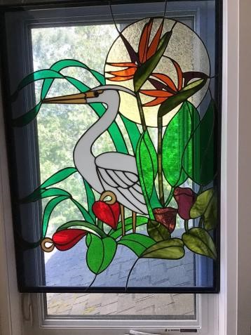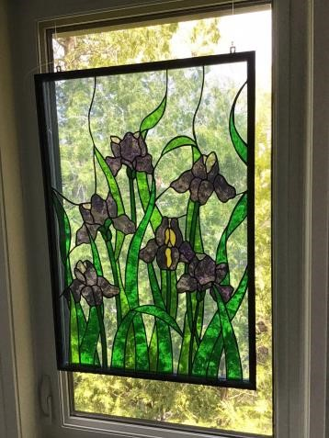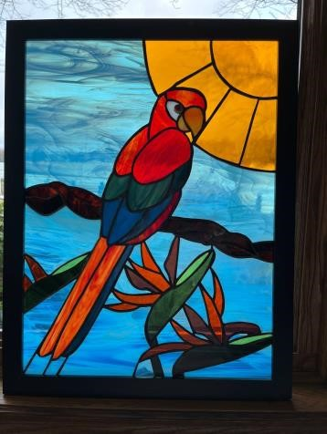

Bridge has become somewhat of an addiction for me. The thing I often need reminding to do as declarer is to "take the time to plan", but I'm usually just so excited to get the play underway. So, I love playing bridge in person or online. Sometimes I come home from a game and say, "Do you know I had a makeable 7NT contract and I didn't finesse! Ughh" or I am yelling at the computer screen "The 10 is good! play it...ughh", and my husband responds saying "You're having fun, right?" Definitely! There's no other game like it.
--------------------------------------------------------------------------------------------------------------------------------------------
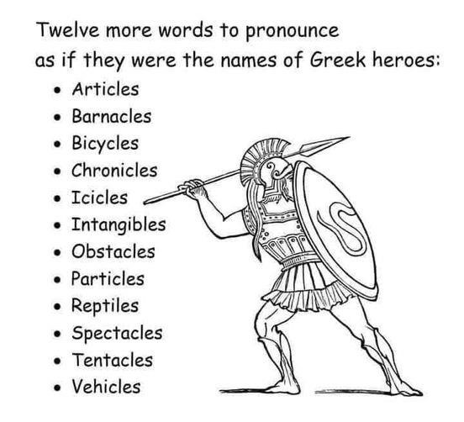

Club Bridge is a social game, and people like knowing who’s playing at their table. When you join some big online game with total strangers, you might just as well be playing a pair of robots. And, who knows ….. maybe you are!?! Connecting a name and face to a BBO handle makes online play more human and more friendly.
Adding your name to BBO is easy. Log in, and select the Account tab from the list down the right side of the screen, and then Profile from the top tabs. Enter your name in the place marked “Real Name”. Your full name is best for clarity - we have eight David’s and 11 Sue/Susan/Suzanne’s at our club! Next, let’s add your picture. At the bottom of the Profile page is a “Profile Image” button. Clicking it brings up some “stock” pictures (not what we want) and the option to load your own photo. Find or take a nice selfie and make sure you know where it is on your device. Now click “Select Picture” in the Upload section, and use the File Browser to choose your picture. Click “Upload Picture” and you’re done! BBO staff must approve your new picture so it may not appear for a while, but when it does we can finally see what you look like!
There is a “Show Profile” button on the Profile page, so you can see yourself as the world sees you. Check it out, and check out your opponents’ profiles next time you play. And remember to say “Hi Dave! Hi Sue!”.
--------------------------------------------------------------------------------------------------------------------------------------------
The Bean Counter
Contributed by Steve Allen, Treasurer

The beaner doesn’t write columns on his birthday. Hope there’s enough hot air to blow out all of the candles.
--------------------------------------------------------------------------------------------------------------------------------

Deal of the Month
June is our membership drive month. But BRAND NEW GRBC members (not renewers) can buy next year’s membership for $70 right now and get more than an extra month of member pricing for F2F games, lessons, and bridge labs. Click here for our membership form.
--------------------------------------------------------------------------------------------------------------------------------

CPR Training
As everyone is aware, our club appeals to an older demographic. It would then be appropriate for GRBC to make CPR training available to as many members as possible. This is to invite members willing to be trained in CPR, or to renew training from past years, to inform the club manager, Doug Grant, including preferred times. Members who have received recent CPR training through other organizations are also invited to advise Doug to that effect. (Written responses please, either in person or to douglass_grant@cbu.ca.)
--------------------------------------------------------------------------------------------------------------------------------
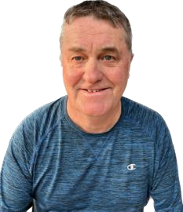 Congratulations to JOE BLAKE who has officially passed his director’s exam
on Wednesday and whom you will no doubt see job shadowing at a game near you.
--------------------------------------------------------------------------------------------------------------------------------
We Were #22!
The latest Bridge Bulletin lists our club as being among the ACBL’s top 50 clubs in terms of table counts for 2022. This was out of a total of 1900+ clubs in ACBL and 1000+ with at least 100 tables F2F and online combined. In fact, we were #5 in Canada (behind one in Ottawa and three in Toronto). We couldn’t do it without you! Thank you for your continuing support!
--------------------------------------------------------------------------------------------------------------------------------
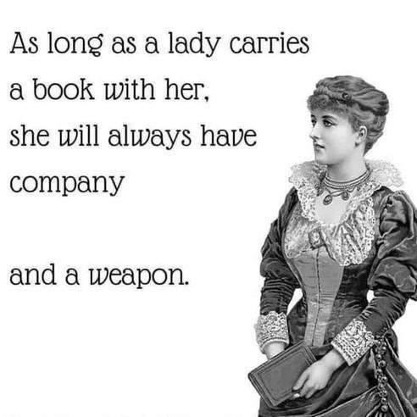

The Answer Lady
Contributed by Susan Lawton

As the “The Answer Lady” I have been responding to questions from “newer” players over the past several weeks. A request has been made to share those players’ questions and my responses in the Alert, essentially a column for the beginner player! You can write to me at suzan2420@yahoo.ca. I have a “small” library of prepared questions, but I would welcome additional questions to build up that library and keep this column viable.

Some weeks when my column ends up in the Alert, I receive lots of feedback and suggestions for a “different” line of thinking. The feedback can take many forms: an email Saturday morning, a chat at the coffee counter or bridge table, suggestions from the esteemed editorial board ..... This was one of those weeks where it seemed everyone had an opinion. For those needing a little refresh, I've included the hand below. Comments included: “I wouldn't bid pre-emptively in first seat”, “Opening with a 2 bid when there is a four-card side spade suit isn't the best practice”, “That hand is too strong or too weak to open with 2”. You get the idea. The concern about opening 2 with this hand is that four-card spade suit. If your partner sitting in North has opening points and a four-card spade suit, you may miss a game in spades.

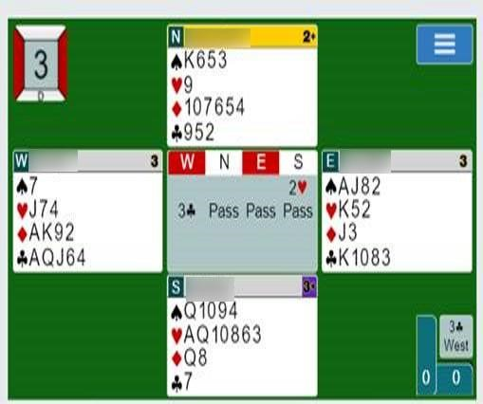

As I outlined in my column of August 1, 2022: The game of bridge has become much more aggressive in terms of bidding over the years, and one area that stands out is those pre-emptive bids. Players now defy all the old rules or guidelines. I was taught that for pre-emptive bids, for example, you need two of the top three honours, you shouldn’t have a four-card major side suit, you can’t pre-empt with a void, you need at least six HCP to open with a pre-emptive bid, etc. These days, players bid early and aggressively, often guided by vulnerability: less aggressive when they are vulnerable and more aggressive when not, especially when opponents are vulnerable. They know they might go down, say one or two even doubled but still end up with a better score, especially if the opponents are vulnerable and can make game.
Here is an excellent example of the power of bidding pre-emptively, not following the 'rules' yet achieving positive results, on a board that my partner and played online recently. At our table, we bid 4, but made six.

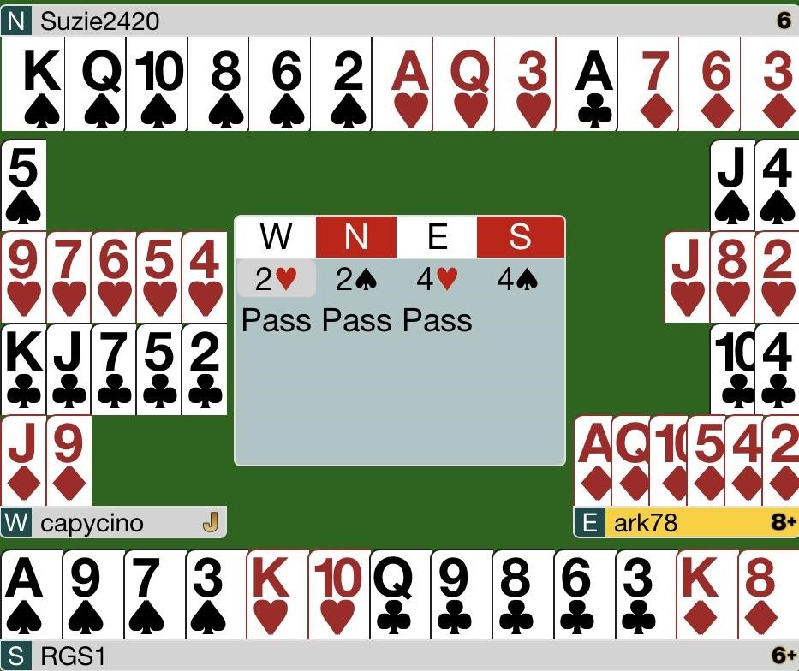

The more successful pairs sitting North/South with no interference: no weak two bids, no overcalls, were able to bid and make 6. They had all the time in the world to describe their hands in a slow and thoughtful approach. North opened 1, South bid 2NT showing opening points and four-card support for spades, 3♣ by North showed shortness in clubs, 4NT was Roman key card Blackwood, and 5♣ showed one or four keycards, and 6 ended the bidding as North knew they were missing one keycard.

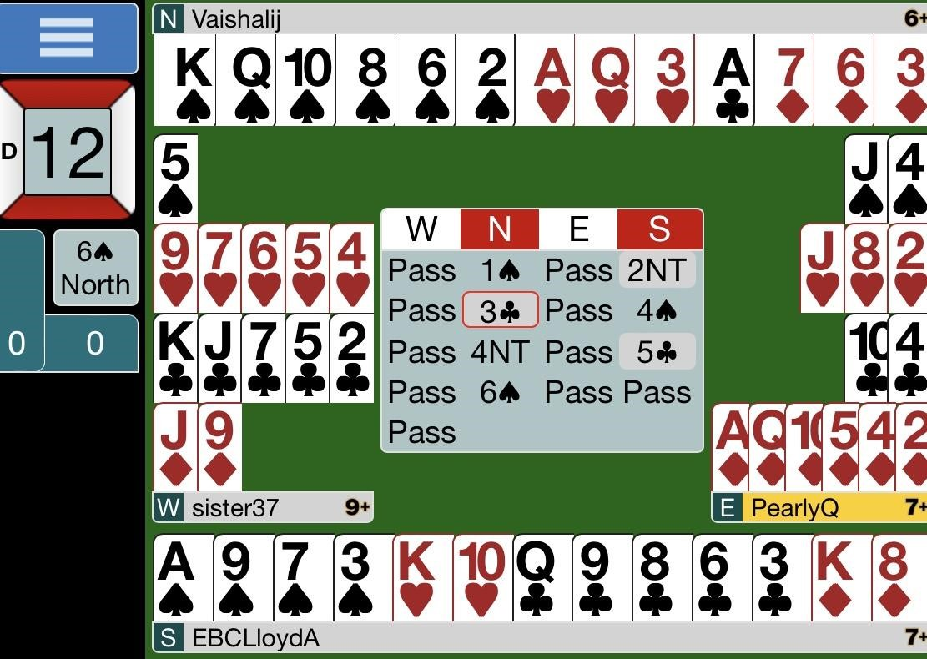

West had only five points, did not have two of the top three honours, (North/South actually had the AKQ!), West's hearts were headed by the 9 and they were sitting in first seat, but even so they did not hesitate one minute in plonking that 2 bidding card down. After I bid 2, East flew right to 4. East/West had a total of 13 points between them, but that didn't slow them down one bit. They were aggressive bidders and took up valuable bidding room, interfering with our ability to communicate and show the strength of our hands.

There is considerable material available for further discussion and learning in this area of preemptive bidding. I have listed three below, but be prepared: there are many differing views. In this highly-controversial area of bridge, “partnership agreement” is key. Decide with your partners what you can tolerate and what you are willing to open pre-emptively, taking care to note what will be the consequences if you are left there and doubled.

Additional Reading
Pat Harrington: Play and Learn, Bridge Bulletin, October 2014, p. 49, November 2014, p. 49.
Robert Todd: http://www.advinbridge.com.
Larry Cohen: https://www.larryco.com/bridge-articles/dont-open-a-weak-2-bid-with-a-side-4card-major
--------------------------------------------------------------------------------------------------------------------------------
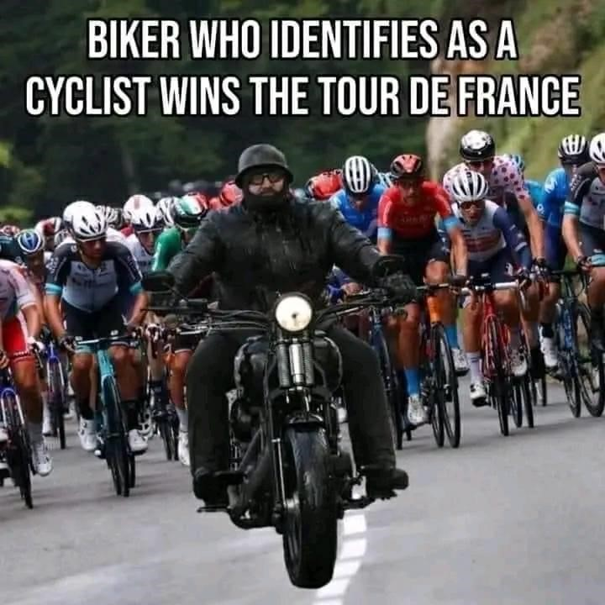

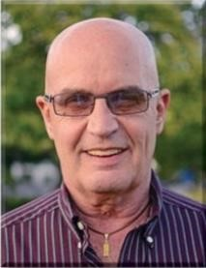 Dear David

All Jump Shifts are Mini-Splinters
If you do not play mini-splinters and have no intention of playing them in the near future, you might want to give this one a pass. If you are playing/interested, here is a cute wrinkle.
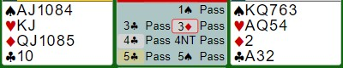
Here is an explanation of what happened at the table. 3♣ showed zero clubs or one club, threeplus spades, and eight-plus HCP. 3♦ asked for clarification. 4♣ showed one club, three-plus spades, and 12-14 HCP. Partner decided to try RKC Blackwood and 5♣ showed one or four key cards. At this point, partner began to worry that there might be two losers in the hand. Frankly, I cannot construct a 12-point hand that doesn’t give you a decent play for slam. However, he took the low road and passed. More than two-thirds of the field bid the cold slam and we got 32% on the board. How can we improve the bidding? Partner suggested that he might have been better off cue-bidding 4♥, showing interest in slam without taking control. Had he done so, I would have bid 4NT myself and then bid slam after partner showed three keycards, hoping that there weren’t two fast losers. Now, I will tell you about the best method. It doesn’t come up often, but you will glad you have it in your bridge toolkit when it does.
The premise behind mini-splinters is that they help you get to games you might not have bid because the HCP are lacking. If a singleton or void is helpful, bid to game. If a mini-splinter response faces a hand with any combination of the K Q J in that suit, you will devalue the worth of those cards and stay out of game. The only thing you give up by playing mini-splinters is a strong jump shift. It is a small price to pay, because there are lots of ways to show your strong hand if you just bid 1♠-2♣.
There are a few small exceptions to “ALL jump shifts are mini-splinters”, but if you accept the premise, let’s try a different auction.
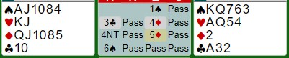
3♣ is a mini-splinter and 4♦ is ALSO a mini-splinter, denoting slam interest if responder has a good hand. 5♦ is zero or three keycards and slam is reached with alacrity. Barring an unlikely ruff, this one should be easy. If you want to count points, East has 15 HCP and West has nine
“useful” points in the majors—a 24-point slam.
--------------------------------------------------------------------------------------------------------------------------------------------

Top Master Point Earners at our Club Contributed by Allen Pengelly

This table lists the individuals who have earned the most master points at our club in each of three master point bands since the beginning of April.

Open Players 499er Players 99er Players
Name MP Name MP Name MP
- David Baker 26.59 1 Barbara Arthur 13.23 1 Debbie Miethig 6.17
- Cindy Mahn 19.13 2 Suzanne Edwards 11.82 2 Sharon Nesbitt 5.82
- Ted Boyd 15.45 3 Shelley Metcalfe 10.74 3 Rick Arthur 5.80 4 Mike Peng 13.89 4 Jim Dalgliesh 9.75 4 Peter Gaasenbeek 5.10
- Colin Harrington 13.51 5 Joan Slover 9.17 5 Audrey Cook 5.08
- Edith Ferber 12.05 6 Lori Cole 8.94 6 Louise Dawdy 4.52
- Neil Jeffrey 11.27 7 Sal Pace 7.84 7 Alicia Wright 3.65 8 John Hanemaayer 10.84 8 Sue Moses 7.77 8 Jim Fox 3.53
- Moira Hollingsworth 10.21 9 Andy Martinek 7.67 9 Pat Pietrek 3.12
- Scott Hills 9.71 10 Steve Allen 7.13 10 Peggi Rieger 3.01
- Bob Griffiths 9.42 11 Brenda Semple 7.06 11 Patricia Gascho 2.74 12 Steven Young 8.85 12 Jack Cole 7.01 12 Kathy Chandler 2.34
- Kathy Russell 8.06 13 Martin Jones 6.97 13 Stu Cowan 2.24
- Dave Quarrie 7.44 14 Nancy Cattanach 6.49 14 Joan Hartviksen 2.15
- Malkin Howes 7.18 15 Noah Pace 6.36 15 Larry Brooks 2.14
- Diane Jamieson 7.17 16 Barbara Lindsay 5.91 15 Steve Cameron 2.13
- Wayne Schroeder 7.04 17 Sue McDonald 5.75 17 John Aldridge 2.12
17 Adriaan Kempe 7.04 18 Nanci Phelan 5.60 18 Casi Zehr 2.11
- Liz McDowell 6.85 18 Bob Giilck 5.60 19 Jane Wilson 2.04
- Neil Coburn 6.61 20 Lynda Burnett 5.42 20 Susan Murray 2.02
- Frank Fischer 6.32 21 David Dennis 5.27 20 Ellen Libertini 2.02
- Susan Lawton 5.65 22 Bob Livermore 5.18 22 Ruthanne Erwin 1.85
- Sandy Graham 5.64 23 Cheryl White 5.07 22 Doug Livesey 1.85 24 Diane Bourdeau 5.50 24 Renate Boucher 4.91 24 Marianne Dziarski 1.78
25 Mary McClelland 5.32 25 Andy Wilson 4.82 25 Richard Wehrle 1.69
-------------------------------------------------------------------------------------------------------------------------------------------

If you would like to play in a particular game but lack a partner that day, you can either:
- For both online and f2f games, log on to Pianola, click on Partner Finder, and create a Partner Finder advert. This needs to be done at least a few hours in advance of the game.
- For online games only, log in to the game in question and register yourself on the Partnership Desk tab.
If you are looking for a regular partner, contact Joan Slover, our membership lead.

We have fun in spades.
We play with all our hearts.
We treat our members like diamonds.
We have a new game director at our club.

