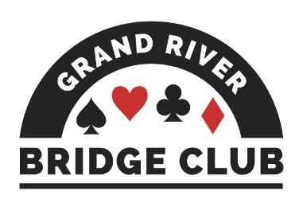PLAY AND LEARN BRIDGE IN A WELCOMING ENVIRONMENT245

ALERT – May 15, 2023

Click here to access our regular game schedule.

Looking Ahead

 Grass Roots FUNd Week, May 8-14 on BBO, double black points, BBO$7
 Our Saturday afternoon online 199er game will switch to a 299er game effective this coming Saturday, May 13. This change was driven by member suggestion.
 Canadian Bridge Championships, Niagara Falls, May 9-19
 Canadian Bridge Federation Regional, Niagara Falls, May 12 – May 19
 All of our F2F games during the week of May 22 will be club championship games (extra masterpoints, no extra cost).
 Spring Niagara-on-the-Lake Sectional, June 2-4, 0-750 tournament
 Sarnia Local Sectional, June 3-4
 June 5-11 will be NAP games at our club (red/black points, extra $2) for all open and 499er games, both F2F and online. The Thursday evening game will be a 2499er game in order to be eligible to be an NAP game.

--------------------------------------------------------------------------------------------------------------------------------------------

A Little-Known Secret
Our F2F 499er game on Thursday afternoons seldom attracts enough players to be a standalone game – so what usually happens is that those 499er players who are present are embedded within the concurrent open game. To a man (and woman), these 499ers say they quite enjoy playing in the open game. There has not been one shark bite to date, while there have been oodles of kindly tips (when requested) and lots of fun and camaraderie. What’s more, some 499ers always earn masterpoints at these sessions, in fact sometimes doing quite well!
So, if you are a 499er, one way or another we’d love to see you on Thursday afternoons at our club!
--------------------------------------------------------------------------------------------------------------------------------------------

Our Club’s Management Team
Although (hopefully) our club appears to operate smoothly and effortlessly – you know, you show up for a game and it runs and you have fun; you show up for your lesson and your teacher appears and you learn a lot – in fact it takes a huge amount of work behind the scenes to make it appear so effortless. And virtually all of this work is performed by volunteers.

This is the fourth in a series profiling the current members of our club’s management team and thanking them and their predecessors for their stellar work. Next up is our special events lead, Joe Blake.

Before we tell you about Joe, however, we need to thank and praise his predecessor, Liz McDowell. Liz was in charge of scheduling all of our special games and contests and parties for something like ten years. So, if you came out and enjoyed one of these events (and noticed how smoothly they always ran), you should take Liz aside and thank her.

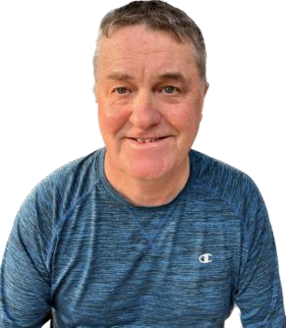
Joe Blake has now taken over from Liz and started making up our yearly schedule, including club championship weeks and NAP games, and STaC and Christmas parties and on and on. Furthermore, as Liz did, Joe also pitches in with the organization of many of these special events. For example, for those of you who came to Barbara Seagram, Joe was the guy in the parking lot! The next special event, just FYI, will be Volunteer Appreciation Day on Tuesday, June 20, which will include both an open game and a 199er game.

Joe’s background is actually in IT, having worked at Sunlife and its predecessor Mutual Life for 34 years, but he is now retired. Somewhat more unusually for a bridge player, Joe’s first job was being a bartender for eight years in Port Dover. Perhaps he should schedule a special cocktail party game for our club and serve everyone fancy drinks! Just a thought!

Joe was inducted into bridge by his colleagues at Mutual Life where they used to have regular games at lunch time. One of those players was Steve Allen (Mr. Bean), and the two of them decided that they would take up duplicate bridge after they retired. Our club came to Joe’s attention on his regular walks along Gage Avenue. But it wasn’t until our club offered a bring-a-friend month in October 2019 that Joe actually crossed our threshold – brought in by Neil Jeffrey who happened to work with Joe’s wife at Manulife. Joe really liked the friendly atmosphere and was amazed and delighted by how welcoming everyone was. He told his friend Steve about our club, and the rest is history.

Joe’s Bridge Tip: Be tolerant of your partner’s mistakes and pick a partner who will be tolerant of yours. Most of all, have fun and enjoy the company of the people you play with.

In other news, Joe will be writing his game director’s exam this coming Tuesday. Please wish him luck! And in other other news, Joe travels a lot, having just returned from South Carolina. Recent trips include Dubai, Thailand, Vietnam, and Cambodia. And in October, he and his wife will head off for Australia, New Zealand, and Fiji.
--------------------------------------------------------------------------------------------------------------------------------------------

At GRBC, you can enjoy coming to our club or playing bridge online via BBO with your friends from anywhere.

In April, our BBO game attendance dropped, so the Board asked for a working group to research and come up with ways in which we can grow our online attendance. This group has been very busy doing just that. They have come up with almost twenty ideas, some big, some small. And one of those ideas is to ask you about your online bridge playing plans now that the warmer weather is coming our way!

Next week, you should receive a short survey. It will probably take about five minutes to fill it out. Please take this time to tell us your thoughts and plans.

PS. This working group calls themselves OTTO (OnTrackToOnline) - check out our logo!

--------------------------------------------------------------------------------------------------------------------------------------------

The Bean Counter
Contributed by Steve Allen, Treasurer
How are you doing with that inflation thingy these days? GRBC has bills to pay just like you.
Here’s where we have “bean” inflated over the last 12 months. Some regular expenses haven’t changed at all! Woohoo!
- Club cleaning (washrooms, lab, tables, floors, etc.)
- Club rent (but it will rise 2% in July)
- BBO/F2F director and teacher pay
- BBO game cost
- TD banking fees
But some costs have changed…
- Dust mats (at the front door) – up 10%
- Landline telephone – up 34%
- Internet – up 6%
- ACBL table count fees – up 18%
- Office/washroom/kitchen supplies and any food that is purchased – up dunno % And some costs will probably go up for future services (billed annually in the fall) … insurance, Pianola….
--------------------------------------------------------------------------------------------------------------------------------

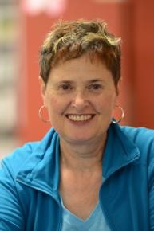 The Answer Lady
Contributed by Susan Lawton

As the “The Answer Lady” I have been responding to questions from “newer” players over the past several weeks. A request has been made to share those players’ questions and my responses in the Alert, essentially a column for the beginner player! You can write to me at suzan2420@yahoo.ca. I have a “small” library of prepared questions, but I would welcome additional questions to build up that library and keep this column viable.

Question
My partner and I, sitting East/West, encountered the hand below. As you can see, South opened with a 2 bid and my partner, West, overcalled with a bid of 3♣. South then passed and as East I was unsure what to do - so I decided to pass as well. In reflecting back, that appeared to be the wrong decision as we made 5♣. Should I have bid? I think I panicked as I thought I needed more points to raise my partner. Signed, an undecided player

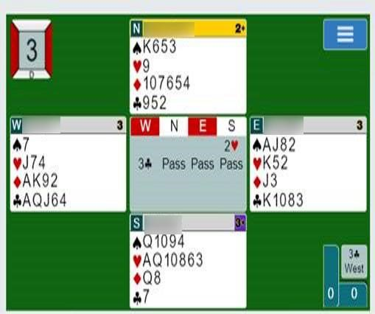

Answer
Thank you, undecided player, for sharing this bidding dilemma. This hand provides a natural teaching sequence from last week's column that provided suggestions for players when opponents open pre-emptively.

South opened 2 in first seat, showing just those six hearts and 6-10 points. West very comfortably bid 3♣, showing an opening hand and at least five clubs. Reviewing the suggested options from last week's column: while West did have 15 points, they did not have stoppers in hearts to bid 2NT or sufficient points to double and bid again. North passed the 3♣ bid with both insufficient points and length to support South's heart suit or bid an alternate suit.

Now we turn to East, what to do? East has 12 points and support for partner's clubs. Despite the 3♣ contract making 5♣ at your table, with proper defense 5♣ should go down. With a heart lead, N/S would win A/Q followed by ruff of a heart by North. So, 5♣ is not the correct bid here.

Another bid to consider would be for East to bid 3NT. East has a stopper in hearts, that is the K, and so nine tricks is a good possibility with East/West having 27 points between them. Yes, there are no stoppers in diamonds in East's hand, but West with opening points must have points somewhere.

A heart lead from South guarantees nine tricks (one heart, one spade, two diamonds, and five clubs). A spade lead will create problems, but declarer can run the clubs and pay very close attention to the North/South discards.

What will South retain with pressure to discard four cards to match the clubs. Will it be the ♦Q setting up dummy’s ♦J of diamonds or perhaps the spades will be shortened? Potentially with good play and a little luck, East/West could produce the same nine tricks: at least one heart, one spade, two diamonds, and five clubs.

It’s so much easier to make nine tricks in 3NT than 11 tricks in 5♣!
--------------------------------------------------------------------------------------------------------------------------------

TIme You Learned our Lessons!

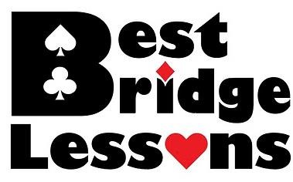
Our September bridge lessons have been scheduled starting Saturday, September 23. They are suitable for absolut beginners or those who have been away from the game for quite a while. Taught by an experienced and highly-qualified instructor, the participants will learn how to play this fascinating and ever-popular game.
Students can come alone or with a partner. No prtevious bridge experience necessary.
Come and learn the rules of the game and how to play hands in our welcoming environment. Our lessons are divided into two five-week sessions, with three weeks in between to give the new players a chance to practise their new learning.

Instructor: Sue Moses
Venue: In our club’s teaching room
Dates: September 23, 30, October 7, 14, & 21 PAUSE November 11, 18, 25, December 2 & 9 Time: 9:30 am – 12:30 pm
Cost: $85 for Beginners 1 (includes the cost of the text), $75 for Beginners 2 (uses the same text)

Click here for more information and to register.
--------------------------------------------------------------------------------------------------------------------------------------------
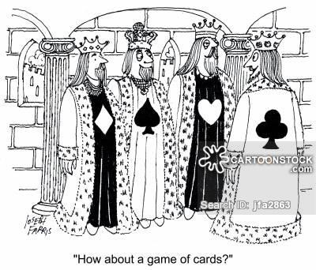

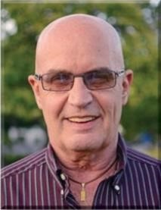 Dear David

All You Had to do was Ask
Here is an addition to your toolkit that might not come up once in the next three years, but you will be glad you have it when the time comes.
Partner opens 1♠ and you resist the urge to immediately bid 6♠. The auction proceeds.
North Deals ♠ A Q 6 4 3
Both Vul ♥ 8
♦ Q 9 5
♣ A Q J 4
 | N
W |  | E
 | S
♣ | ♣
♠ K J 7
♥ A Q 7
♦ A K 8 7 3 ♣ K 10
West | North East | South
 | 1 ♠ Pass | 2 NT¹
Pass | 3 ♥² Pass | 4 NT³
Pass | 5 ♠⁴ Pass | ?
♠ 10 9 8 ♠ 5 2
♥ K J 10 6 4 ♥ 9 5 3 2
♦ J 10 6 2 ♦ 4
2 9 8 7 6 5 3
- 3+ spades, 10+HCP
- 0 or 1 heart
- 1430 RCK Blackwood)
- 2 keycards with the queen
At this point, it appears as if your only possible losers are in the diamond suit, so if you could ascertain what partner has in diamonds, you might be able to bid a grand slam. Here’s how. After partner responds to 4NT, a new suit at the six level asks partner whether he has thirdround control of the bid suit. What does third-round control mean? Qxx, Qx, or even a singleton Q constitutes third-round control. Another kind of third-round control is shortness in the suit: xx, x, or void.
How do you respond when partner asks for third-round control? If you don’t have either, you bid 6♠. If you have the ♦Q, you bid 6NT. If you have shortness, bid 7♠. Here’s why there are two methods for showing third-round control. Suppose you hold: ♠KJ2 ♥A32 ♦AKJ1032 ♣2. With the same auction, if partner bids 6♠, 7♠ is still a favorite to make, but it may fail if partner has xxx or xxxx. If partner bids 7♠ (showing shortness), he may have to trump a diamond to set them up. However, if partner bids 6NT (showing the ♦Q), count your tricks: five spades, one heart, six diamonds and one club = 13 tricks. You can joyously bid 7NT. This agreement doesn’t come up a lot but, when it does, you will be glad you have it in your toolkit.
This was the actual hand. Although North responded 6NT, South could not count to 13 tricks in NT, even knowing that his partner held the ♦Q, so he bid the safe 7♠ As you can see, North’s beautiful club suit made it easy.
--------------------------------------------------------------------------------------------------------------------------------------------

No. 112 | ♠ AJ109  ♥ J72  ♦ AQ  ♣ AQ106

♠ 854
♥ KQ10
♦ 9632
♣ K32
West | North East | South
 | 1♣ Dbl | 1NT
Pass | 3NT All pass

In the South seat I was declarer after this simple auction. West led the ♠6. I called for dummy’s ♠9 and East took the trick with his ♠Q. Next came the ♥4 which I won with the ♥10 in my hand, West following suit. If you were in my shoes, what would you do now?

SOLUTION

You have eight sure tricks: two spades, two hearts, one diamond, and three clubs. The question thus becomes - where can you get that ninth trick? The bidding tells you that the diamond finesse won’t work. If clubs are divided 3-3, you will have no problem at all - but of course I wouldn’t be writing this if it were that easy……..

So, should you test clubs first? No, because if they don’t split 3-3, you would soon be at the opponents’ mercy in the other suits. Starting with hearts isn’t a good idea either because you have only one more stopper in that suit.

The best solution is to begin by working on spades. It is true that there are two losers in the suit, but it’s highly likely that you have only two losers because if East had had five spades he would have bid 1♠ instead of doubling.

So, at Trick 3, lead a spade from your hand. West will play a small spade and you play dummy’s ♠10. No surprise, it will lose to East’s ♠K. At this point East’s best defence is to cash his ♥A and exit with another heart, which you will win with your ♥K (West will follow suit).

Continuing with your plan, at Trick 6 you cash your good spades. Both opponents will follow suit to the third trick. So now you cash your fourth spade and force the opponents to discard. You can safely discard a diamond from your hand while gathering very useful information. Here is the situation right before you cash your ♠A.

♠ A
♥
♦ AQ
♣ AQ106
♠ ♠
♥ ♥ 8
♦ J8754 ♦ K10
♣ 87#112 ♣ J954
♠ ♥
♦ 9632
♣ K32

When you cash dummy’s ♠A, the only card East can spare is the ♥8. The fact that he discards a winning card tells you that he must be trying to guard both minor suits, meaning that his remaining cards must be two diamonds headed by the ♦K and four clubs headed by the ♣J. Armed with this inference, you can endplay East in either diamonds or clubs.
- If you choose diamonds, you can cash your ♦A and then lead the ♦Q. East will be forced to take his ♦K and then lead away from his clubs.
- If you choose clubs, you can cash your ♣AKQ and put East in with your fourth club. East will be forced to take his ♣J and lead away from his diamonds.
Here is the complete deal. |  | ♠ AJ109  ♥ J72  ♦ AQJake  ♣ AQ106
♠ 632 ♠ KQ7 ♥ 963 ♥ A854
♦ J8754 ♦ K10
♣ 87#112 ♣ J954
♠ 854
♥ KQ10
♦ 9632
♣ K32

When declaring a no-trump contact, it is often very helpful to run your long suit and force the opponents to discard - since their discards are frequently very informative.
--------------------------------------------------------------------------------------------------------------------------------------------
Top Master Point Earners at our Club Contributed by Allen Pengelly

This table lists the individuals who have earned the most master points at our club in each of three master point bands since the beginning of April.

Open Players
Name MP
1 David Baker 25.54 2 Cindy Mahn 18.39
- Colin Harrington 13.51
- Ted Boyd 13.47
- Mike Peng 11.51
- Edith Ferber 11.00
- John Hanemaayer 10.60 8 Moira Hollingsworth 10.21
9 Neil Jeffrey 9.41 10 Robert Griffiths 8.95
- Stephen Young 8.85
- Kathy Russell 7.53 13 Malkin Howes 7.18 14 Scott Hills 7.02 15 Liz McDowell 6.83 16 Adriaan Kempe 6.54 17 Wayne Schroeder 6.20
18 Dave Quarrie 6.07 19 Diane Bourdeau 5.50
20 Diane Jamieson 5.22 20 Paul Latimer 5.22
22 Susan Lawton 5.12 23 Mary McClelland 5.08
- Steve Carpenter 5.07
- Neil Coburn 4.71 499er Players 99er Players
Name MP Name MP
1 Barbara Arthur 11.47 1 Rick Arthur 5.80 2 Suzanne Edwards 10.09 2 Peter Gaasenbeek 5.10
  - Shelley Metcalfe 8.53 3 Debbie Miethig 4.51
  - Lori Cole 7.34 4 Louise Dawdy 4.23
  - Sal Pace 7.17 5 Sharon Nesbitt 4.13
  - Andy Martinek 6.74 6 Alicia Wright 3.65
  - Jim Dalgliesh 6.66 7 Audrey Cook 3.42
  - Sue Moses 6.47 8 Jim Fox 2.57
  - Steve Allen 6.38 9 Peggi Rieger 2.42
  - Nancy Cattanach 6.18 10 Pat Pietrek 2.41
  - Brenda Semple 6.10 11 Kathy Chandler 2.34
  - Martin Jones 6.04 12 Patricia Gascho 2.15
  - Noah Pace 5.69 13 Larry Brooks 2.14
  - Barbara Lindsay 5.43 14 Jane Wilson 2.04
  - Lynda Burnett 5.42 15 Susan Murray 2.02
  - Jack Cole 5.41 15 Ellen Libertini 2.02
  - Bob Giilck 5.33 17 Stu Cowan 1.97
  - Nanci Phelan 5.23 18 Douglas Livesey 1.85
  - Cheryl White 5.07 19 Casi Zehr 1.82
  - Renate Boucher 4.91 20 Don O’Bright 1.69
  - Joan Slover 4.78 20 Richard Wehrle 1.69
  - Judy Beauchamp 4.48 22 Carolyn Israel 1.62
  - David Dennis 4.36 22 Dona Reinhart 1.62
  - Molly Worden 4.25 24 Randall DeKraker 1.56
  - Andy Wilson 4.10 25 Ruthanne Erwin 1.54

-------------------------------------------------------------------------------------------------------------------------------------------

If you would like to play in a particular game but lack a partner that day, you can either:
  - For both online and f2f games, log on to Pianola, click on Partner Finder, and create a Partner Finder advert. This needs to be done at least a few hours in advance of the game.
  - For online games only, log in to the game in question and register yourself on the Partnership Desk tab.
If you are looking for a regular partner, contact Joan Slover, our membership lead.

We have fun in spades.
We play with all our hearts.
We treat our members like diamonds.
We always run our long suits at our club.

