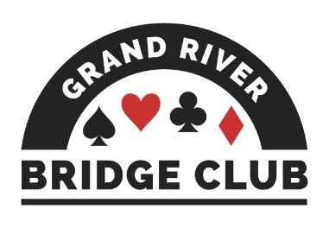PLAY AND LEARN BRIDGE IN A WELCOMING ENVIRONMENT245

ALERT – May 1, 2023

Click here to access our regular game schedule.

Looking Ahead

 Our virtual games on Saturday, April 29 and Sunday, April 30 will be Silver Linings Games, 150% silver points, $7BBO.
 Our Friday, April 28 499er F2F game will be a local charity game ($2 surcharge), the proceeds of which will go to the Waterloo Food Bank. Extra masterpoints.
 Barbara Seagram will be at our club on Wednesday, May 3. Registration is now closed.
 During the first week of May, all of our F2F games will be club championship games (extra masterpoints, no extra cost).
 Canadian Bridge Federation Regional, Niagara Falls, May 12 – May 19
--------------------------------------------------------------------------------------------------------------------------------------------

Gatlinburg, Part 1
A bunch of our players have spent the last week in Gatlinburg, Tennessee, battling for the glory of our club. A fuller report will appear in next week’s Alert. For now, you will have to content yourself with these photos sent in by Edith Ferber. Although you should be sure to read Margot Stockie’s exciting and important message below…..

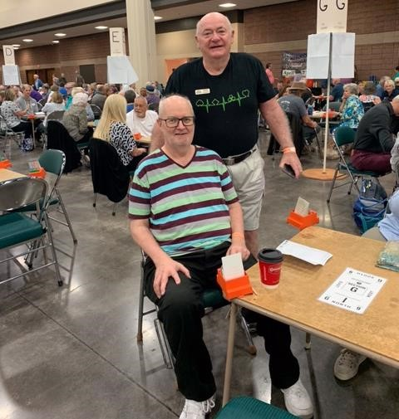

Roy Dandyk and Dave Quarrie won the gold rush once and placed several times. It was Roy’s first time at this tournament.
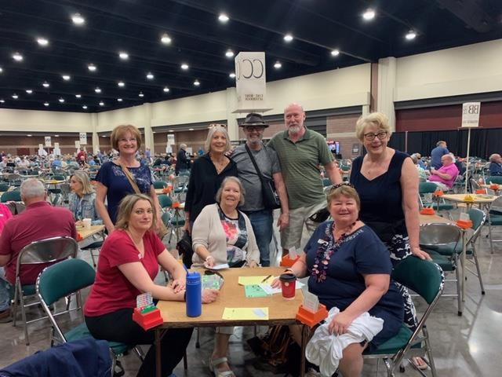

From left to right: Moira Hollingsworth, Kathy Russell,
Margot Stockie, Thea Davis, Dave Baker, Dave
Longstaff, Mary McClelland, and Sharon King

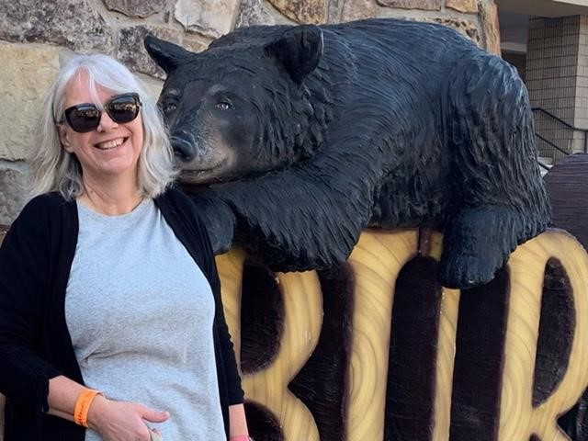 Diane Bourdeau and a new friend

It was Kathy Russell’s first time at this tournament.

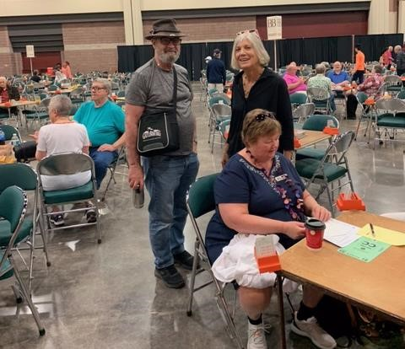

Dave Baker, Margot Stockie, and Mary McClelland

--------------------------------------------------------------------------------------------------------------------------------------------

Our Club’s Management Team
Although (hopefully) our club appears to operate smoothly and effortlessly – you know, you show up for a game and it runs and you have fun; you show up for your lesson and your teacher appears and you learn a lot – in fact it takes a huge amount of work behind the scenes to make it appear so effortless. And virtually all of this work is performed by volunteers.

This is the second in a series profiling the current members of our club’s management team and thanking them and their predecessors for their stellar work. Next up is our technology lead, Paul Latimer.
Of course, we need to start by thanking Paul’s predecessors Mircea Giurgeu and Grant Roberts. Mircea’s help was invaluable when we were feeling our way at the start 11 years ago – he got us set up with Internet and communications and computers and our website and all that good stuff. After a couple of years, Grant took up the torch and kept us linked in through our many changes of venue up to and including our current location. Grant also set up our teaching AV arrangement, was the key person in the establishment of our virtual games, and served on three committees simultaneously – the management team, the games committee, and the board of directors! Grant also was kind enough to recruit his successor, to wit….

Paul Latimer
Paul is very modest about his contributions to the club. He says he looks after our computer and our network but that generally there isn’t all that much for him to do. Paul has set up a Google drive location so that members of the club’s committees can access various administrative and governance documents, and he spends a surprising amount of time showing people how and where to find these documents. ☺ Besides that, Paul helps out with anything technical at our club and is on call for emergencies.
Paul studied math and computer sciences at the University of Waterloo. During that time, he learned to play bridge in the cafeteria (sound familiar?) and got hooked. He played at the ARC with Terry Visentin whenever they could manage it, but then Terry moved to Winnipeg and Paul started having kids. Paul got a job at the NCR (he was there for 35 years) and played some bridge at lunchtime there. It was at the NCR that he met John Hanemaayer, a bridge player who was interested in using the Precision bidding system and who taught it to Paul. They played when they could where they could when bridge games lined up with their schedules, but it really wasn’t all that often.
Paul is a math guy, and so his best tip is that counting – counting suits and counting tricks and counting points - is the road to success. If you count, you will take more tricks, period.
When asked why he likes bridge, Paul says that it is the most interesting game in the world. You never get the same hand and, unlike chess, part of the game is hidden from you. As well, the human element adds to the fascination and fun. Paul says that there are always gales of laughter at his table. He and his partner are definitely “out for a good time, not for a good score”.
--------------------------------------------------------------------------------------------------------------------------------------------

What Could Go Wrong?

Contributed by Margot Stockie
Playing bridge is a wonderful way to connect with people from all ages, backgrounds, and interests (other than bridge), and it is why we love to go to tournaments. On Sunday April 16, a group of bridge players from the Guelph and Grand River bridge clubs headed off to Gatlinburg to play in what is American’s largest regional tournament. Many of us had been there several times. Our van had six in it and, although full (we make our own dinners all week so need lots of groceries and kitchen gadgets and some alcohol for medicinal purposes), we had our lunch, Bridge
Bulletins to challenge ourselves with “The Bidding Box”, our phones and iPads to do Wordle, Quordle, Octordle…..(you get the drift), eReaders, and knitting!! Nerds of the world unite! While driving in Kentucky, the van started to make some disturbing noises. We stopped to check it out and got the okay to keep going. Our driver slowed down and we hoped we could make it the rest of the way but that was not to be. In preparation for the trip, the winter tires had been switched out for the summer tires. If you don’t believe that “wheels need to be re-torqued after tires are changed”, you are in danger of all-of-a-sudden watching one of your tires passing your car while rolling down the highway, crossing to the far side, and stopping in an upright position against the guardrail without hitting anything. (Not a defence but only 30-40% of drivers come back after the recommended 100 kilometres to have that done.)
Dave Longstaff (our hero) was driving and managed to get us safely to the side of the road with great skill. He probably saved our lives. We were then helped by a young man who is in the National Guard, a Tennessee state trooper, and a very co-operative tow truck driver. C.J. (the young guardsman) drove four of our group all the way to our condo in Gatlinburg, and Jeremy (the tow-truck driver) drove Dave and me and the van to the condo. All of this in time to enjoy our dinner and get unpacked and organized before a late bedtime. I can guarantee that as much as we can find the humour in our predicament now, it was very difficult for me to get back in a vehicle to get groceries the next day. We were all shaking for hours.
The rest of the week was full of lots of good bridge, delicious food, camaraderie, late nights, and the odd squabble that we all expect!! It has been suggested that eventually we all live in the same old folks home so that we can talk about our bridge adventures forever.
--------------------------------------------------------------------------------------------------------------------------------------------

We still have a large online playing community of more than 100 members. Why are people still playing online? Playing online bridge serves many needs: convenience, caution, tracking of bids and play for learning, ability to play remotely when away, convalescing and many other medical conditions. . . and more. Many of us may find ourselves in these situations at different times throughout the year.
The world since Covid looks different. Things that were created just to survive are now “normal”, such as businesses allowing work from home. At GRBC we now find ourselves in new territory as a hybrid club with both Face-to-Face and Online players. We need both groups to be happy for our club to flourish.
In April, we are seeing a continual drop in table counts and, when our online games get too small, fewer people want to play in them and they will crash. So, let's get together now to grow our online games. We hope that you will choose to support GRBC online BBO games as much as possible, because that helps keep the lights on in our bricks and mortar club. By keeping our online games strong, we all win. We thank you!

The Bean Counter
Contributed by Steve Allen, Treasurer

Managing the finances of the GRBC is no different than managing any business. Let’s suppose we were running a Tim Horton’s franchise. We would love to have loyal coffee customers that spend regularly. Maybe they buy a muffin with that coffee! We would love to have strangers visit us and buy a double-double, but (alas) we may never see them again. Jazzy marketing, coffee promotions and evolving menus aim to grow our business or at least sustain it … but we really have no control over any of that - we rely on customers showing up. It would be ideal to have predictable cash flow so we would know that we can pay our bills each month.

Time moves on. Our coffee business is breaking even every month and then a terrible thing happens. People switch to an alternate pick-me-up beverage. Customers start making their own coffee at home. McDonald’s opens up across town charging $1/coffee. Houston, we have a problem.

This is the case with GRBC’s online “coffee” (the blue bars, below). BBO table counts have been dropping (even though our club’s actual coffee is free).

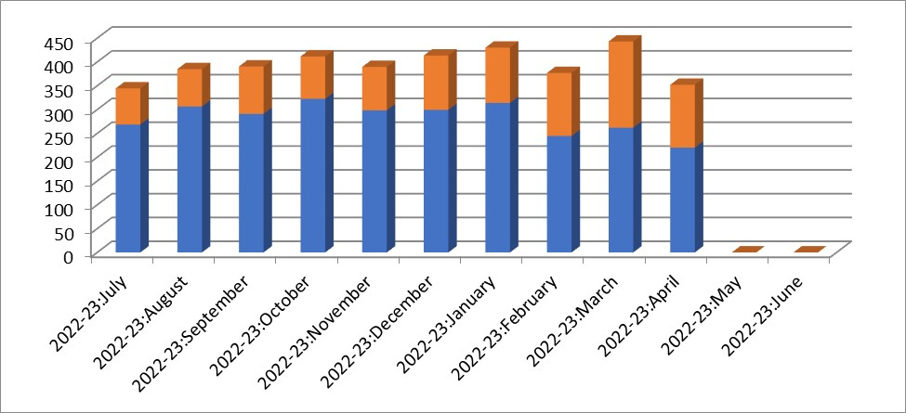
*There are a few days left in April 2023 that are not represented on the chart.

While it’s true that F2F generates more income per table, BBO income is vital to the success of our bridge club. Historically each brings in ~50% of the income required to cover the ~$10,000 costs each month (see the April 14th ALERT). While F2F income is trending “level”, this drop in BBO table counts will translate into a shortage each month (say, $1,000). Did I make you thirsty for a coffee? Please … buy one of ours!
--------------------------------------------------------------------------------------------------------------------------------

The Answer Lady

Contributed by Susan Lawton

As the “The Answer Lady” I have been responding to questions from “newer” players over the past several weeks. A request has been made to share those players’ questions and my responses in the Alert, essentially a column for the beginner player! You can write to me at suzan2420@yahoo.ca. I have a “small” library of prepared questions, but I would welcome additional questions to build up that library and keep this column viable.

Question
My partner and I played this hand in a 99 game and it left us wondering how we should have handled it. I was seated in the West position. At all tables, East opened 1N, showing 15-17 points. From there on, the bidding varied a lot.
At two tables, South passed and West transferred to diamonds. At one of these tables, that transfer was accomplished with a 2 bid, with East responding 3♣ and then West correcting to 3♦. At another table, West bid 3♣ and East responded 3♦. That ended the bidding at both tables and resulted in a contract of 3♦.
At the other four tables, South interfered by bidding 2 to show their long spade suit or in one case 2 which was alerted as a spade suit. The sequence of bidding by East was different at all four tables, with two tables ending up in 2N, one in 3N, and one in 5♦. The successful contracts were 2NT, 3♦, and even 5♦, while the 3NT contract went down one.
Answer Lady, all these variations in bidding prompted several questions and discussion between my partner and me. Can you answer our questions? Hopefully your responses will help us refine our bidding when a long minor suit exists in Responder’s hand and Opener bids 1NT.

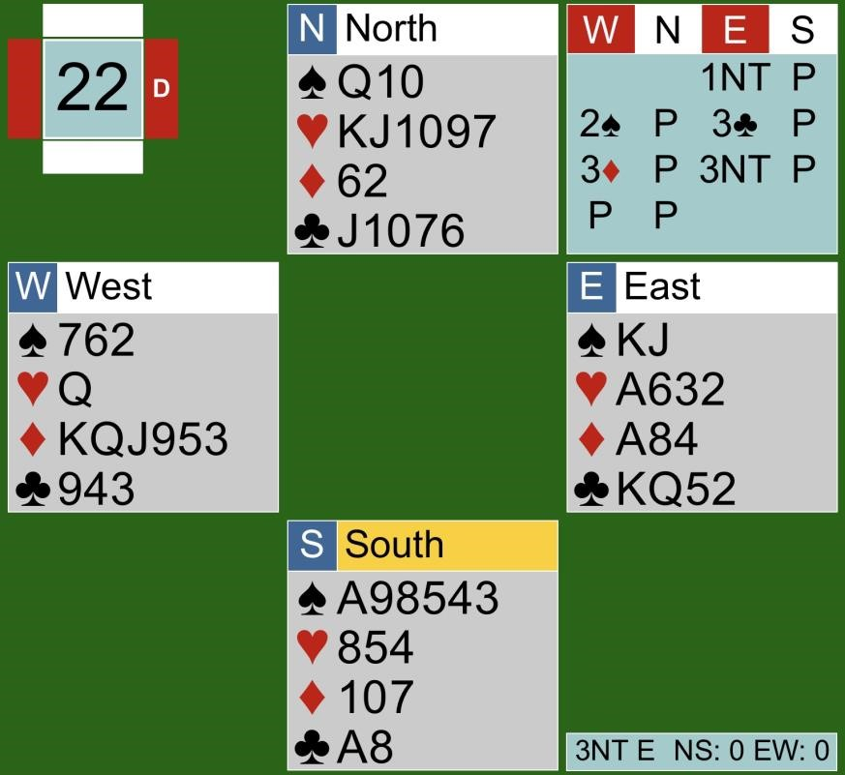
Thank you `99' player for your interesting questions.

Question 1
To transfer to diamonds after a 1N opening bid by partner, which method is generally preferred:
2 leading to 3♣ then a correction to 3♦? Or is the right bid 3♣, then Opener would correct to 3♦?

Answer 1
Transfers to a minor after a 1NT opening are typically used to show a weakish hand with a long minor suit, that is six-plus cards in that suit. (With a transfer to a major suit, readers may remember a minimum of five cards in hearts of spades is required for that transfer.) As a bid at the three-level occurs in a minor suit, six-plus cards in clubs or diamonds are necessary to make the transfer. Generally speaking, pairs must have a partnership agreement to make those minor transfers. You have identified a couple of methods, namely the 2 bid and the 3♣ bid. There are other variations as well, and you pays your money and you takes your chances. One advantage to using a 3♣ bid is that Opener ends up declaring the contract meaning that the big hand is hidden. On this hand Responder has only eight points but he does have six diamonds, a great opportunity to use a minor transfer. So have a chat with your partner and reach an understanding on how you would like to handle minor transfers.

Question 2
Is it better to end up in 3N or 5♦ in this type of situation? I assume that generally 3N would be preferred.

Answer 2
It is usually preferable to be playing in 3NT rather than 5♦. The rationale: you need to make only nine tricks in a 3NT contract while 5♦ requires 11 tricks. Sometimes, however, interference means that a 3NT contract is not a viable option. And of course you do have to have stoppers in every suit.
On this hand, with only eight points and six diamonds it would be perfectly acceptable to pass after that 3♦ contract has been reached. Of course, several pairs defied the odds by bidding on. One pair jumped immediately to 3NT after the 3♦ bid. Another pair reached 5♦. While the 5♦ contract was a successful one, the 3NT contract went down. Heading to 5♦ or 3NT after that minor transfer is a risky bid and not a strategy I would recommend. Yes, there are six diamonds and East has three, including the ♦A and ♦J, but East has no knowledge of the strength in West's hand. Today there are eight points, but on another day there could be considerably fewer – since most transfers to a minor are made with pretty weak hands (with more than eight points, Responder should definitely be thinking about 3NT).
--------------------------------------------------------------------------------------------------------------------------------
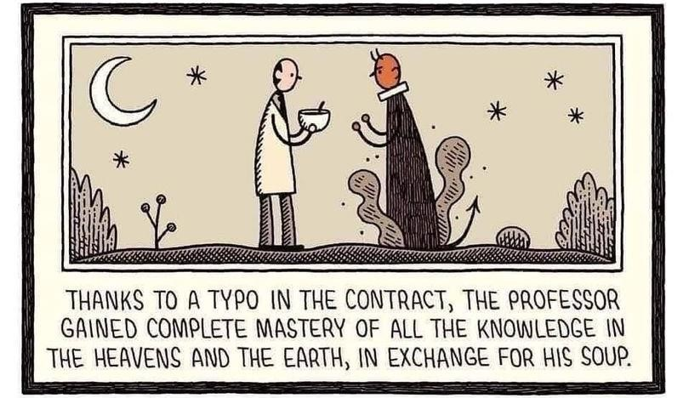

Don’t Let the Old Man (or Woman) In
Contributed by Malkin Howes
Clint Eastwood and Toby Keith were sharing a golf cart at Eastwood’s charity tournament in Pebble Beach, CA when Toby asked Clint: “How do you remain so young and active?” It was the eve of Eastwood’s 88th birthday and Eastwood was starting work on a new movie the next day. Clint replied: “I just get up every morning and go out. And I don’t let the old man in”. This inspired Keith to write his iconic song “Don’t Let the Old Man In”.
Human beings (with the exception of Clint Eastwood, apparently) are innately lazy. Our brains are hard-wired to follow the path of least resistance, and this was an excellent survival strategy back in the day when it was important to conserve energy. But our hunter-gatherer ancestors didn’t live to be very old, and following the path of least resistance turns out to be a poor strategy for older people. It is now well accepted that the best way to slow the aging process is to take on new challenges and force yourself to do stuff you don’t feel like doing.
What has this got to do with bridge you ask? In a word, online bridge.
Playing online is convenient and non-effortful, and it can be very tempting to stay in your pajamas and cocoon with your iPad. But that is letting the old man in. Much better to make the effort to get dressed, drive to your bridge club, and see your friends.
Seniors who challenge their brains, keep moving, and maintain social connections reap benefits that go far beyond the enjoyment that comes from their active lifestyles.
Use it or lose it. Push yourself. Do hard things. Don’t let the old man in.
--------------------------------------------------------------------------------------------------------------------------------
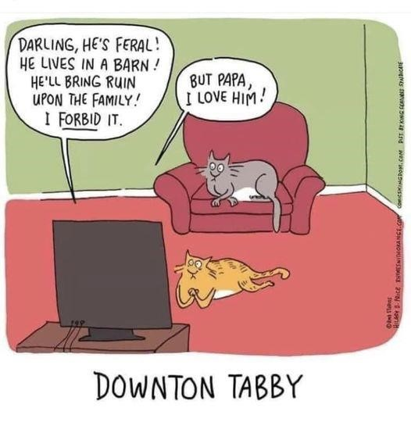

TIme You Learned our Lessons!

Our Precision Bidding System module has been postponed until the fall due to low enrollment.
--------------------------------------------------------------------------------------------------------------------------------------------

Bridge at Tournaments
Joan Slover would like to draw your attention to this enjoyable quickie video (eight minutes) about playing bridge at tournaments. Our very own Dianne Aves appears briefly in the video.
--------------------------------------------------------------------------------------------------------------------------------------------

Dirty Tricks
Gord Hunter would like to draw your attention to this fascinating feature-length documentary about a cheating scandal that rocked the world of élite competitive bridge. Click here for the trailer. Right now, you can stream Dirty Tricks only if you subscribe to Crave or Paramount. Both streaming services do have a one-week free trial period….
--------------------------------------------------------------------------------------------------------------------------------------------
Can You Help?
A very nice gentleman from Cambridge, a new member to our club and a fairly decent player, would appreciate a ride to our club so he can play in our 299er and 499er games. He is also in search of a regular partner. If you can help out (with either or both), please contact Joan Slover.
--------------------------------------------------------------------------------------------------------------------------------------------

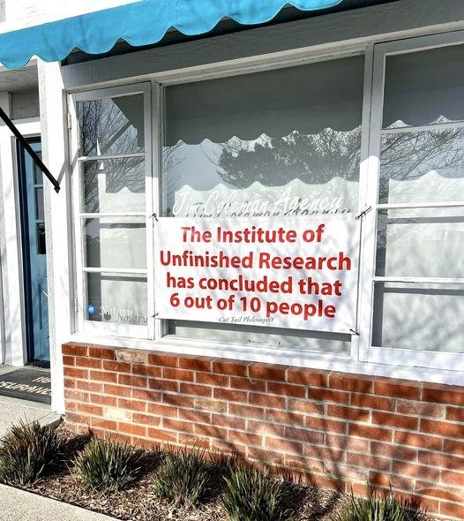

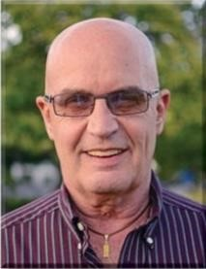 Dear David

Stoppers

I have been asked many times over the years, “How do you show stoppers when you are trying to get to 3NT?” I would attempt to explain the process within two minutes, leaving the person that asked confused and myself disappointed with my explanation. I saw a hand in the January Bulletin (It’s Your Call, pg. 44) that has prompted me to try again.
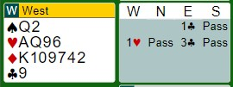
No feedback about the 1♥ bid!
West has an 11-point hand worth an opening, so game is strongly suggested after partner’s jump in clubs. It is time to cue bid. If West had sure stoppers in spades and diamonds, she would bid 3NT. Examples of stoppers:
Ax, KQ, QJ10, J109x. With stoppers in only one suit, you
bid that suit. Partner is cleared to bid 3NT with a stopper in the other suit. There is one other rare mechanism you can use to get to 3NT. If West cue bids 3♦ and East bids 3♠, East is showing a semi-stopper in spades. A semi-stopper is Qx, Jxx or singleton K. On this example, Jxx or singleton K opposite your Q2 will produce a stopper. Two semi-stoppers equal one stopper, since the opponents cannot attack the suit without giving you a trick. DO NOT try this unless you have a long-time partner and you have discussed this extensively. Take two Tylenols before reading on. The hand above was relatively easy to navigate, even if you omit the semi-stopper scenario, because you have room at the three-level to show either stopper. Let us proceed to the actual Bulletin hand where there is no room to show both stoppers.
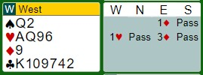
After flipping the minor suits, how can you investigate whether you belong in 3NT? A 3NT bid would show stoppers in both black suits. A 3♠ bid would show a spade stopper and deny a club stopper. The only real solution seems to suggest bidding 3NT with hope in your heart, but you are extremely nervous about the fact that partner
did not bid 1♠ over 1♥, strongly suggesting she has fewer than four spades. Here is my solution. When only one suit is available to cue bid (like this example), bidding that suit asks partner to bid 3NT with a stopper in the suit bid. It would also suggest that West has a club stopper, since why would she be trying for 3NT with no stopper in either black suit. Instead, bidding 3NT would show a spade stopper. The 3NT bidder may or may-not have a club stopper but that is less of a problem than the danger of opener having less than four spades, as mentioned above.
Finally, I will show the actual Bulletin hand.
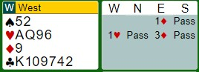
Call Votes Award
3♠ 5 100
Pass 5 90
3NT 4 80
4♣ 0 40
The actual hand is complicated by the fact that perhaps
the hand is not good enough for a game. The expert panel who chose 3♠ were quite divided on the meaning that bid. Daniel Korbel chose 3♠, saying: “I think the general consensus is that this asks rather than tells. My second choice is pass.” 😀 Told you to take Tylenol!
No. 111 | ♠ K5Jake  ♥ AJ97  ♦ AJ5  ♣ AJ97

♠ AQJ1084
♥ Q1084
♦ K87#111
♣ Jake
West | North East | South
 |  | 1♠
Pass | 2♣ Pass | 2♥
Pass | 4NT Pass | 6♣1
Pass | 6♥ All pass
1. One or three keycards, void in clubs

West led the ♠7. If you were in my shoes as declarer, what would you do now?

SOLUTION

You have two possible losers – the ♥K and the ♦Q. You can get rid of the diamond loser on the
♣A, so what’s the problem? In fact, if the heart finesse wins, you even can make an overtrick, right?

According to the proverb, one should always hope for the best but prepare for the worst. What could go wrong?
- You should keep it in mind that if you have been dealt a hand that includes a singleton or a void, the law of symmetry suggests that your opponents are also likely to have hands with singletons or voids.
- In addition, you should take into account that even though you bid spades, West insisted on leading the suit. This is a screamer.

Let’s say you finesse in hearts and East wins. What card will East play next? A good partner returns his partner’s lead, and in this case East might practically break his wrist in his haste to put a spade on the table. Oh well, down one is good bridge.
So, is the right play to win the opening lead in dummy and play the ♥A right away? Not bad, but you can do a little better. Win the spade lead in your hand and put the ♥Q on the table to tempt West to cover. You have nothing to lose. If your gambit fails, overtake your ♥Q with the ♥A and continue trumps. You will go down only when East started with the doubleton king and West started with three small trumps. This is only about a 14% chance. In other words, you have an approximately 86% chance to make your contract.

Here is the complete deal.
♠ K5Jake
♥ AJ97
♦ AJ5
♣ AJ97
♠ 7Jake ♠ 9632
♥ 32#111 ♥ K65
♦ 10964 ♦ Q32Jake
♣ Q86432 ♣ K105
♠ AQJ1084
♥ Q1084
♦ K87#111
♣ Jake

As you can see, if you finesse in hearts, East will take the trick with his ♥K and return a spade giving his partner a ruff for down one. Your partner may say “nice try, partner” or “bad luck, partner”, but you will know in your heart that you should have made this contract.
--------------------------------------------------------------------------------------------------------------------------------------------
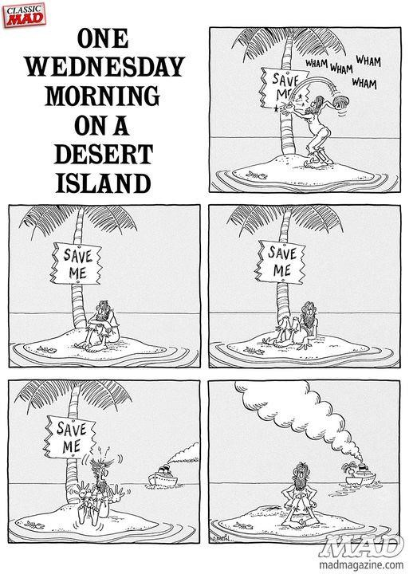

Top Master Point Earners at our Club

Contributed by Allen Pengelly
WILL RETURN

-------------------------------------------------------------------------------------------------------------------------------------------

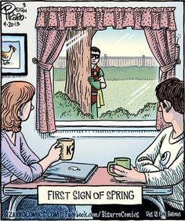

If you would like to play in a particular game but lack a partner that day, you can either:
- For both online and f2f games, log on to Pianola, click on Partner Finder, and create a Partner Finder advert. This needs to be done at least a few hours in advance of the game.
- For online games only, log in to the game in question and register yourself on the Partnership Desk tab.
If you are looking for a regular partner, contact Joan Slover, our membership lead.

We have fun in spades.
We play with all our hearts.
We treat our members like diamonds.
We support the Food Bank at our club.

